Student name:__________
- "Create" is the highest skill in Bloom's Taxonomy.
- true
- false

- "Understand" is the lowest skill in Bloom's Taxonomy.
- true
- false

- "Remember" is a higher skill than "Understand" in Bloom's Taxonomy.
- true
- false

- "Ask the Right Question" is one of the desired skills for accounting professionals, consistent with EY's "The Analytics Mindset".
- true
- false

- "Communicate results with management" is one of the desired skills for accounting professionals, consistent with EY's "The Analytics Mindset".
- true
- false

- "Extract, Transform and Load Relevant Data" is one of the desired skills for accounting professionals, consistent with EY's "The Analytics Mindset".
- true
- false

- Of the options listed below, which is the lowest level of thinking skills in Bloom's Taxonomy?
              - Create
              - Understand
              - Apply
              - Analyze

- Of the options listed below, which is the highest level of thinking skills in Bloom's Taxonomy?
              - Evaluate
              - Apply
              - Analyze
              - Understand

- Which is the appropriate ordering of thinking skills in Bloom's Taxonomy, where the ">" symbol means higher order skills?
              - Evaluate > Apply
              - Remember > Understand
              - Apply > Analyze
              - Analyze > Evaluate

- Which component of the AMPS model would usually involve creating a pivottable?
              - Ask the Question
              - Master the Data
              - Perform the Analysis
              - Share the Story

- Which component of the AMPS model most appropriately addresses the skill mentioned by EY's analytics mindset of "extract, transform and load relevant data"?
              - Ask the Question
              - Master the Data
              - Perform the Analysis
              - Share the Story

- Use of a dashboard to track relevant outcomes would be consistent with which component of the AMPS model?
              - Ask the Question
              - Master the Data
              - Perform the Analysis
              - Share the Story

- A visualization may be used to help with which component of the AMPS model?
              - Ask the Question
              - Master the Data
              - Perform the Analysis
              - Share the Story

- Benford's law might be used as part of which component of the AMPS model?
              - Ask the Question
              - Master the Data
              - Perform the Analysis
              - Share the Story

- What type of question(s) works to explain "Why did overall tax increase even though net income did not?"
              - What happened? What is happening?
              - Why did it happen? What are the root causes of past results?
              - Will it happen in the future? What is the probability something will happen? Is it forecastable?
              - What should we do based on what we expect will happen? How do we optimize our performance based on potential constraints?

- What type of question is used in finding the level of sales needed to break even?
              - What happened? What is happening?
              - Why did it happen? What are the root causes of past results?
              - Will it happen in the future? What is the probability something will happen? Is it forecastable?
              - What should we do based on what we expect will happen? How do we optimize our performance based on potential constraints?

- What type of question is used in learning how much the company paid in interest expenses last year?
              - What happened? What is happening?
              - Why did it happen? What are the root causes of past results?
              - Will it happen in the future? What is the probability something will happen? Is it forecastable?
              - What should we do based on what we expect will happen? What should we do based on what we expect will happen? How do we optimize our performance based on potential constraints?

- What type of question is predicting whether borrowers will be able to repay their loans?
              - What happened? What is happening?
              - Why did it happen? What are the root causes of past results?
              - Will it happen in the future? What is the probability something will happen? Is it forecastable?
              - What should we do based on what we expect will happen? How do we optimize our performance based on potential constraints?

- What type of question is used in determining how to maximize revenues if there is a trade war with China?
              - What happened? What is happening?
              - Why did it happen? What are the root causes of past results?
              - Will it happen in the future? What is the probability something will happen? Is it forecastable?
              - What should we do based on what we expect will happen? How do we optimize our performance based on potential constraints?

- The accuracy, validity and consistency of data used and stored over time is called
              - data veracity.
              - data integrity.
              - data quality.
              - truthful data.

- Dashboards showing current company performance are usually associated with
              - dynamic updating.
              - static updating.
              - opportunist updating.
              - monthly.

- What may hinder the work of the accountant due to receiving too much information?
              - Information availability
              - Information accessibility
              - Information deficits
              - Information overload

- Over the past two years alone, what percent of the data in the world has been generated?
              - 50 percent
              - 90 percent
              - 75 percent
              - 80 percent

- According to the textbook, the job of the accountant is continuing to change from that of data collection to data
              - analyst.
              - scientist.
              - interpreter.
              - curator.

- What serves as a graphical summary of various measures tracked by a company?
              - trackboard
              - graphical interface
              - dashboard
              - web page

- According to EY's Analytics Mindset, accounting professionals need to be able to:
              - program their accounting analysis.
              - interpret and share the results with shareholders.
              - ask questions answerable with data.
              - reduce the available data to a manageable level.

- According to EY's Analytics Mindset, accounting professionals need to be able to:
              - program their accounting analysis.
              - produce visualizations for stakeholders.
              - ask the right questions.
              - reduce the available data to a manageable level.

- The third step of the AMPS model is
              - master the data.
              - perform the data testing.
              - perform the analysis.
              - pick appropriate data.

- As accountants of the future require higher levels of critical thinking and reasoning skills than what was previously required for accountants, which levels of critical thinking skills as outlined by Bloom’s Taxonomy should accountants need to focus?
              - Remember, Understand, Apply
              - Create, Evaluate, and Analyze
              - Remember, Create, and Apply
              - Curiosity, Evaluate, Understand

- The AMPS model is
              - linear insofar that there is a one-way progression from A->M->P->S.
              - cyclical insofar that the model allows more refined questions.
              - random and since each component is equal, these can be done in any sequence.
              - exponential since each component is the product of prior components.

- Which common visualization type would be used to compare values?
              - Pie chart
              - Bar chart
              - Line Graph
              - Scatterplot

- Which common visualization type would be used to evaluate the composition of values?
              - Pie chart
              - Bar chart
              - Line Graph
              - Scatterplot

- A line graph would be used for which visualization purpose?
              - Comparison of values
              - Distribution of values
              - Trends of values over time
              - Relationships between values

- A scatterplot would be used for which visualization purpose?
              - Comparison of values
              - Distribution of values
              - Composition of values
              - Relationships between values

- Which step of the AMPS model is emphasized by the use of Power BI?
              - Ask the Question
              - Master the Data
              - Perform the Analysis
              - Share the Story

- Which step of the AMPS model is emphasized by the use of Alteryx?
              - Ask the Question
              - Share the Story
              - Perform the Analysis
              - Master the Data

- Which data analysis specialty task is emphasized by the use of the Tableau software tool?
              - Data Visualization
              - Data Analysis
              - Data Acquisition
              - Data Preparation

- Which software tool would be considered to be a data acquisition and preparation tool, a data analysis tool and a data visualization tool?
              - Alteryx
              - Python
              - SQL
              - Excel

- Based on Lab 1-1 Excel Journal Entries to Trial Balance, using the Exhibit below, determine the appropriate debit balance of Accounts Receivable after the Calculated Balances computes the net debit balance.
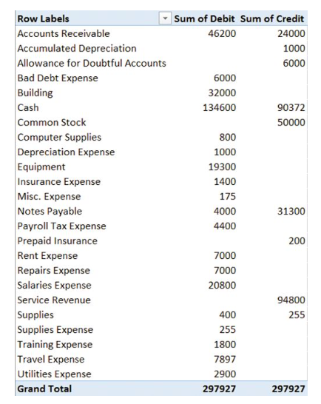
              - $46,200 debit
              - $24,000 debit
              - $22,200 debit
              - $22,200 credit

- Based on Lab 1-2 Excel Calculating Depreciation Using Excel Functions, and using the exhibit below, if the SLN Excel command =SLN(Cost, Salvage, Life), what is the appropriate formula for cell F4?
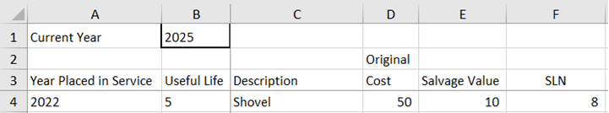
              - =SLN(D4,E4,B4)
              - =SLN(D4,E4,B1)
              - =SLN(D4,E4,A4)
              - =SLN(B4,E4,D4)

- Based on Lab 1-3 Excel Creating a Mortgage Amortization Schedule, and the figure below, if the mortgage is being paid over 15 years (or 180 months) instead of 30 years (or 360 months), will the monthly payment be higher or lower?
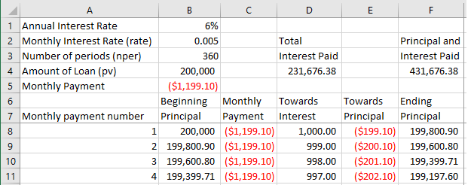
              - higher
              - lower
              - cannot be determined

- Based on Lab 1-3 Excel Creating a Mortgage Amortization Schedule, and the figure below, if the mortgage is being paid over 15 years (or 180 months) instead of 30 years (or 360 months), will the total interest over the life of the loan be higher or lower?
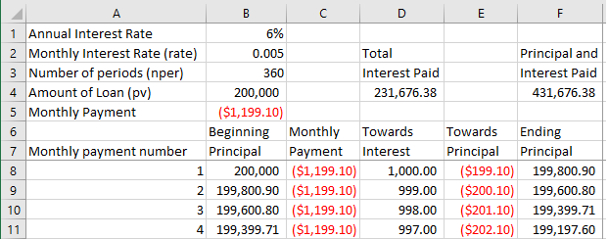
              - higher
              - lower
              - cannot be determined

Answer Key
Test name: chapter 1
          - TRUE
          - FALSE
          - FALSE
          - TRUE
          - TRUE
          - TRUE
          - B
          - A
          - A
          - C
          - B
          - D
          - D
          - C
          - B
          - D
          - A
          - C
          - D
          - B
          - A
          - D
          - B
          - A
          - C
          - B
          - C
          - C
          - B
          - B
          - B
          - A
          - C
          - D
          - D
          - D
          - A
          - D
          - C
          - A
          - A
          - B

