Student name:__________
MULTIPLE CHOICE - Choose the one alternative that best completes the statement or answers the question.
1) The quantity 0.0000064 g expressed in scientific notation.
A) 6.4 × 10⁶ g
B) 6.4 × 10⁻⁶ g
C) 6.4 × 10⁷ g
D) 6.4 × 10⁻⁷ g

2) The quantity 8.7 × 10⁵ g expressed in standard decimal notation.
A) 0.000087 g
B) 870.000 g
C) 0.0000087 g
D) 870,000 g

3) A substance that can be broken down into two or more simpler substances by chemical methods is called a(n)
A) compound.
B) mixture.
C) element.
D) isotope.

4) On a periodic table, the columns of elements with similar properties are
A) periods.
B) groups.
C) rows.
D) metals.

5) The most numerous of the elements are the
A) metals.
B) nonmetals.
C) metalloids.
D) noble gases.

6) Which is not a mixture?
A) A jar filled with rocks and sand
B) Seawater
C) A glass of Kool-Aid
D) Sodium chloride

7) Which is not a pure substance?
A) Helium
B) Copper wire
C) Air
D) Sucrose

8) Which squares contain mixtures?
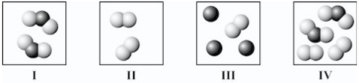
A) II and III only
B) III and IV only
C) I, III, and IV only
D) I and IV only

9) Which square(s) contain(s) only an element?
A) I only
B) II only
C) I and II only
D) III and IV only

10) Which symbols represent only elements that are metals?
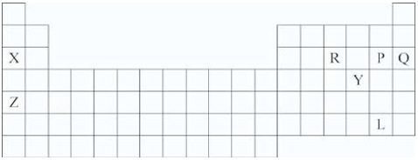
A) X and Z
B) X and Q
C) P and L
D) X, R, P, and Q

11) Which symbol(s) represent(s) elements in the noble gas family?
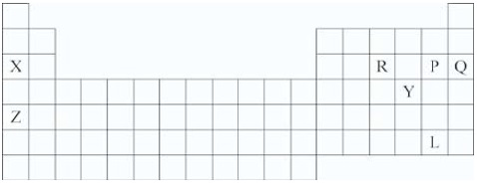
A) X and Z
B) P and L
C) Q
D) Y

12) Which differentiates a compound from a mixture of two or more elements?
A) The elements in a compound may be present in varying proportions
B) A compound does not exhibit the individual properties of the elements of which it is composed
C) A compound is made up of only one element
D) A compound cannot be made up of more than two elements

13) Which substance is an element?
A) NO₂
B) NaCl
C) N₂
D) CH₄

14) A(n) __________ is a fixed number of atoms held together by chemical bonds in a certain spatial arrangement.
A) element
B) ion
C) molecule
D) mixture

15) Which diagram(s) best represent(s) only diatomic molecules?
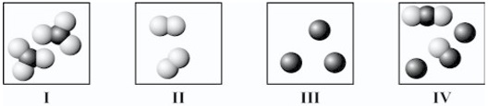
A) I only
B) II only
C) I and II only
D) II and IV only

16) Which diagram(s) best represent(s) only molecules?
A) I only
B) II only
C) III only
D) I and II only
E) IV only

17) Which diagram(s) best represent(s) only individual atoms?
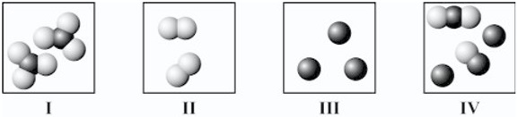
A) I only
B) II only
C) III only
D) IV only
E) II and III only

18) Which of the following is the chemical symbol for silver?
A) Au
B) Pb
C) Ag
D) Fe

19) Which of the following is a pure substance?
A) Lemonade
B) Concrete
C) Gasoline
D) Silver wire

20) Which square(s) contain(s) only one or more compounds?
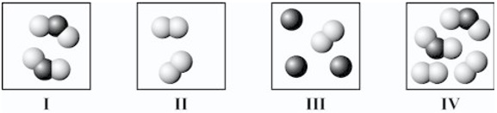
A) I only
B) II only
C) I and IV only
D) II and III only

21) In the periodic table, which elements typically have similar properties?
A) Those in the same rows
B) Those related diagonally
C) Those in the same columns
D) Those on opposite sides

22) The nucleus of an atom contains
A) electrons and protons only.
B) protons only.
C) electrons, protons, and neutrons.
D) protons and neutrons only.

23) What distinguishes the atoms of one element from another?
A) The number of neutrons
B) The number of protons plus neutrons
C) The number of protons
D) The number of neutrons plus electrons

24) The atomic number is the
A) same as the mass number of an atom.
B) number of protons in a nucleus.
C) number of protons and neutrons in a nucleus.
D) number of neutrons in a nucleus.

25) The majority of new smartphones being released have displays that are at least 5 inches in size. What is this size in centimeters? (There are 2.54 cm in one inch.)
A) 1.97 cm
B) 6.10 cm
C) 12.7 cm
D) 60.0 cm

26) One common class of minerals are aluminosilicates, with a general formula of Al₂SiO₅. What is the atomic percentage composition of aluminum in an aluminosilicate?
A) 12.5 percent Al
B) 25 percent Al
C) 33.3 percent Al
D) 62.5 percent Al

27) Which one of the following is a subatomic particle located in the center of the atom and has a positive charge?
A) Protons
B) Neutrons
C) Electrons
D) Photons

28) Which one of these materials is most likely to conduct heat?
A) A titanium rod
B) A sample of chlorine gas
C) A silicon wafer
D) A chunk of phosphorus

29) What type of material is defined as having a well-ordered atomic structure?
A) Amorphous
B) Crystalline
C) Transparent
D) Opaque

30) What are the three pillars of sustainability?
A) Reduce, reuse, recycle
B) Equitability, justice, quality of life
C) Diversity, efficiency, toxicity
D) Environmental, social, economic

31) Which country is the world's leading producer of rare earth elements?
A) USA
B) China
C) South Africa
D) Brazil

32) A recent set of advertisements has a picture of an aluminum can with an aluminum-frame bicycle, along with a hypothetical quote from the can that reads: “I want to be a bike. Recycle me.” The analysis of the life cycle of an item starting with its raw materials and ending with the used item becoming the raw material for new products is called
A) cradle-to-grave.
B) reusability.
C) cradle-to-cradle.
D) cost-benefit analysis.

33) Which one of the following is an example of a homogeneous mixture?
A) A chocolate chip cookie
B) A glass of pulp-free lemonade
C) A carbonated beverage
D) A bowl of cereal in milk

34) What is the density of a block of material that is 12 cm × 6 cm × 2 cm and has a mass of 356 g?
A) 1.00 g/cm³
B) 2.47 g/cm³
C) 3.56 g/cm³
D) 4.95 g/cm³

35) How many cm are in 0.129 m?
A) 1.29 cm
B) 12.9 cm
C) 129 cm
D) 1290 cm

36) What term is defined as the flow of electrons from one location to another?
A) Resistance
B) Transparency
C) Density
D) Electricity

37) A sample of silicon rejected for use in an electronic circuit has an impurity of boron at a level of 3 parts per billion. What is the fraction of boron atoms in the silicon sample as written in scientific notation?
A) 3 × 10⁻⁹
B) 3 × 10⁹
C) 3 × 10⁻¹²
D) 3 × 10⁻⁶

38) What is the term used to describe a material that allows light to mostly pass through it?
A) Reflective
B) Porous
C) Transparent
D) Absorbtive

39) How many protons are in an atom of carbon?
A) 2
B) 4
C) 6
D) 12

40) Which of the following states of matter has a definite shape?
A) Solid
B) Liquid
C) Gas
D) Plasma

41) Matter is anything that occupies space and has a __________.
A) density
B) volume
C) mass
D) color

42) In which of the following phases are the particles farthest from each other?
A) Solid
B) Liquid
C) Gas
D) Need more information

43) Different elemental forms of carbon such as diamond and graphite are referred to as __________.
A) isotopes
B) allotropes
C) isomers
D) isotropes

44) What multistep process is used to separate pure metals from ore?
A) Mining
B) Leaching
C) Metallurgy
D) Grinding

45) Which of the following is a physical change?
A) Melting of ice
B) Burning of gasoline
C) Baking a cake
D) Fermenting of grapes

46) Which of the following is a chemical change?
A) Boiling water
B) Melting wax
C) Cracking glass
D) Souring milk

Answer Key
Test name: chapter 1
1) B
Negative powers of ten move the decimal to the left.
2) D
Positive powers of ten move the decimal to the right.
3) A
Mixtures are separable by physical means.
4) B
Periods and rows go across.
5) A
These are green in the periodic table in your textbook.
6) D
Mixtures include more than one pure substance.
7) C
Mixtures are not pure substances.
8) B
Mixtures will have different substances in the same box.
9) B
Elements will only have one type of atom in the box.
10) A
Nonmetals reside in the upper right corner of the periodic table.
11) C
Noble gases are in the far-right column of the periodic table.
12) B
Remember that compounds are elements bound together by chemical bonds.
13) C
Only one has just one symbol in the formula.
14) C
Remember which of these have more than one element that are also bonded together.
15) B
The prefix di- means two.
16) D
Molecules have multiple atom bound together.
17) C
The atoms are not bound to other atoms.
18) C
19) D
Remember that pure substances have only one component.
20) A
Different compounds will have different combinations of different elements.
21) C
Groups are those with similar properties.
22) D
Remember that the massive particles are in the nucleus while the electrons orbit around the outside.
23) C
Remember that the number of protons is the atomic number and that defines who the element is.
24) B
The protons define the element.
25) C
26) C
27) A
28) A
29) B
30) D
31) B
32) C
33) B
34) B
35) B
36) D
37) A
38) C
39) C
40) A
41) C
42) C
43) B
44) C
45) A
46) D

