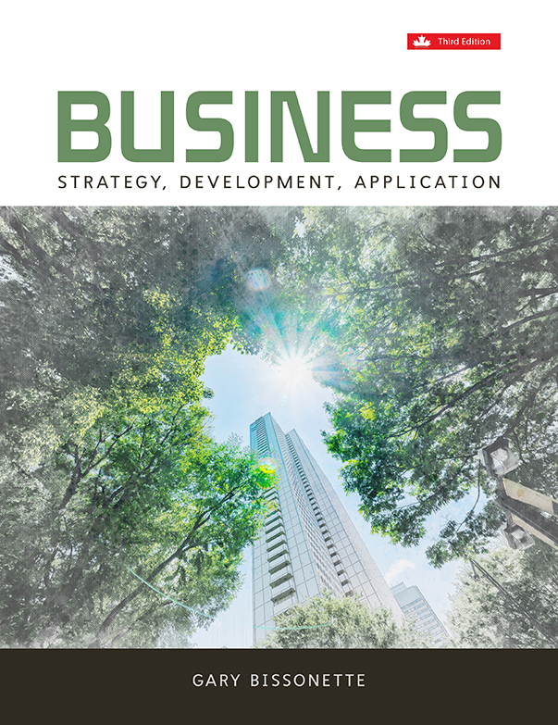

Chapter 1: What Is Business?

Chapter Summary

In this chapter, we have described the nature of business and discussed the ways in which businesses create profits and interact with the marketplace in order to meet the needs, wants, and desires of targeted customers. Our discussion focused on the interaction of business as a commercial endeavour, guided by employee interaction and supported by organizational efficiency and structure, which results in the development of a business system and, ultimately, a business model designed to deliver desired goods and services to the marketplace. Utilizing productive resources at their disposal (assets, labour, capital, and managerial acumen), businesses seek to drive a profit from the sale of such goods and services and ensure long-term profitability and growth by continually seeking to make the most efficient use of their resources. While striving for profitability, businesses are being increasingly challenged by customers, and the marketplace at large, to be good corporate citizens, acknowledging their responsibility to act in a socially acceptable manner and respecting the finite nature and scarcity of resources. This new requirement of businesses is resulting in a significant emphasis on resource sustainability and environmental initiatives. To help you to understand why some companies are more successful than others, this chapter’s focus emphasizes the importance of positioning, and developing and communicating a value proposition to the customer group that a business is trying to attract in a manner that differentiates the business’s products and services from those of its direct competitors, and that attempts to develop and sustain a competitive advantage in the marketplace. The creation of this value proposition takes into consideration both tangible and intangible benefits that the product or service offers, and looks to determine the extent at which price will become a key decision criterion within the customer’s purchase decision. The chapter closes with a discussion associated with the importance and interrelationship between strategy and tactics and the need for managers to recognize that in order to be successful, businesses not only have to properly develop a plan for attacking the marketplace, but also must be effective in the implementation of this plan.

Learning Objectives

This chapter is designed to provide students with:
- A macro-level understanding of what business is
- An overview of the major components of a business model and how their successful development and execution determines business performance
- An awareness of the overarching role of the business owner or “C-suite” management team
- An understanding of how businesses plan
- Exposure to the concept of visionary leadership
- Via a Management Reflection, an overview of the relationship between business strategy and business model development, and the importance of successfully executing both for a business to achieve its identified objectives
- Via an Appendix, an introduction to the difference between profit and profitability

Management Reflection – The Business Decision-Making Landscape

Being in business goes beyond simply developing your value proposition and understanding its asset base and cost structure. It is about being able to understand the macro environment around you; the resources, capability, and capacity that you possess; and the ability to communicate to the marketplace the uniqueness and importance of the products/services you offer. At its core base, developing and managing a business requires its owners/managers to:
- create a vision of the opportunity in the marketplace
- confirm that the market size of customers is large enough that, once commercialized, the opportunity can enable the organization to make a profit and sustain this profitability for the anticipated planning cycle and beyond
- confirm that a position within the market is feasible, which will enable the company to compete in a manner that is superior to its direct competition
- confirm that the market situation will stay constant long enough for the business plan to be developed and executed confirm that the business has the resource base and the capability to execute the strategy
- execute the strategy in an efficient and effective manner, achieving the objectives set forth within the business plan created

As this process demonstrates (see Figure 1.14 Business Decision-Making Model), being in business is really a question of developing strategy and executing tactics across your business model.

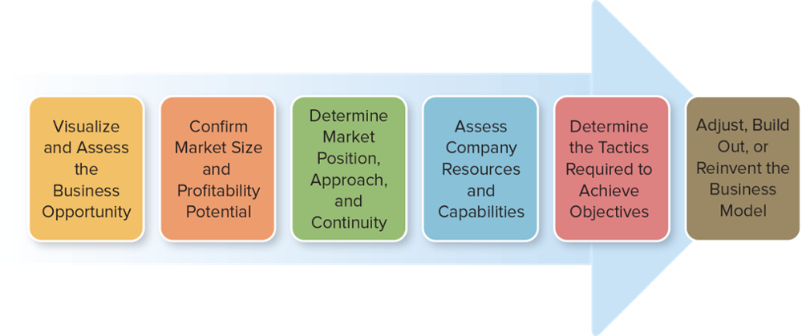

Strategy is the development of plans and decisions that will guide the direction of the firm and determine its long-term performance. Strategy focuses on the vision of the firm and the opportunity it believes exists in the marketplace. It also checks that the life expectancy of the product or service is long enough to ensure that the initial investment can be recovered and that the firm can make a profit. Finally, strategy development assesses whether the firm has the competencies and resources to compete in this targeted market. Tactics are the immediate term actions that a firm executes to meet the short-term objectives set forth in the current planning cycle. Tactics can be thought of as the action items a firm undertakes to ensure that it is successful in achieving its strategic objectives. Tactics could involve the expenditure of money for new equipment, the hiring of new staff with specialized skills, or the manufacturing processes undertaken to develop a product or service. To successfully grow a company, the management team has to be successful in both planning strategy and executing tactics. Strategically, managers need to understand where the market is going and how their products and services will fit into the market and meet customer needs. Tactically, they need to ensure that the right product reaches the right customer at the right time, and at the right place for the right price. As noted earlier, Chapter 6 outlines in more detail the strategic planning process and the relationship between strategy and tactics. The intent here is just to introduce these concepts so that you get a sense as to their overall importance in managing a business. Their introduction now also will make them easier for you to understand as you move through this course and textbook.
As managers, in conducting business we need to avoid the temptation to become predominantly focused on short-term results. Managers need to make decisions in recognition of both immediate needs and longer-term requirements in order to protect and grow the general health of the organization. A key aspect of this process is to understand that business (and the marketplace) is not static, but dynamic. It is changing all the time. What has worked in the past may not necessarily work in the future. As an example, Blockbuster Inc. built its market leader position in the movie rental marketplace on the basis of a bricks-and-mortar (physical store locations) business model. Successful in the 1970s, 80s, and 90s, this model gave way to video streaming, downloading, and competitive intensity from market entrants such as Netflix, Redbox, Amazon, cable companies, and mobile device and content distributors (Rogers, Bell, Telus, etc.). The end result is that, by failing to change, Blockbuster went from market leader, valued at more than $500 million (USD) to a financially challenged organization in little over four years, with $900+ million (USD) in debt and $1.1 billion (USD) in losses. It ultimately was forced to liquidate its assets due to its inability to meet its debt obligations in 2010.22
For managers, Blockbuster and other examples like it provide a constant reminder that we must continually assess and reassess market conditions and the customers they serve. Innovation and reinvention of how to conduct business and where to compete are becoming more fundamental to business planning than ever before. Visionary leadership and the ability to anticipate new market space and new market opportunities are necessary skills of today’s managers. Managers must also recognize that the decisions they make impact both internal and external stakeholders. These stakeholders expect managers to conduct business in a manner that is ethical, socially responsible, and mindful of the sustainability requirements of our world.
Having said all of this, building, growing, and managing a company is one of the most rewarding experiences an individual will ever have. The feeling of accomplishment of a job well done is second to none. Welcome to the world of business—it’s a career choice filled with excitement and never-ending challenge.

Business IN ACTION Overview

- Microsoft – Reinventing the Business Model focuses on the dramatic transformation which Satya Nadella has been leading Microsoft through as it changes its business model from a laptop/desktop centric software and services provider to that of a cloud-based player. Critical to this update’s focal point is the understanding that business models are changing more rapidly than ever before and that existing business models may no longer fit in the disruptive business environments which many businesses find themselves within.

- Canadian Tire – Building out the Business Model – offers insight into the change which Canadian Tire’s business model has under gone as it pivots from a model largely built around the dealer network to that of a much more centralized corporate-owned focused operation. The key role of acquisitions and technology investments is also commented up, as core to this overall transformative process.

- BlackBerry – Reinventing the Business Model – provides students with a glimpse into the world of turnaround strategies and the methodologies used to right-direct a company and its underlying business model which has found itself in a downward spiral.

- Toyota – Building for a Greener Future – Offers students an insight into the increasing emphasis which environmental sensitivity and climate challenges are having on the managerial decision-making process which drives the overall evolution of strategy and the planning cycles associated with its execution.

- Women – Visionary Leaders in their Own Right – comments on the growing influence of women within the C-Suite, and the overall success that many of these visionary leaders are achieving. Canadian female CEO executives are identified, thereby enabling all to sense the role model capabilities of women aspiring to reach these leadership levels.

Key Takeaways (Chapter Highlights)

- The efficiency and effectiveness of a business entity can be assessed against three fundamental characteristics: the commercial endeavours it undertakes, its human resource (employee) interaction model, and its organizational efficiency and structure.

- A key component of managing any business is understanding the expenses that must be considered when setting the price of a product/service offering.

- Companies develop value propositions for the purpose of communicating to customers how their products/services are different and the important benefits which they offer.

- Business models are, as a result of the analysis provided above, the manner and structure by which we conduct business on a day-to-day basis, and reflect conscious decisions relating to resource deployment in route to developing revenue and driving profit.

- The role of the business owner or management team is to anticipate, recognize, or sense an opportunity to create a product or to deliver a service that is felt to be unique, important, and of value (meaningful) to a targeted customer or customers.

- The failure to meet the objectives of a planning cycle can be the result of poor positioning, poor operational execution, or a combination of the two.

- Visionary leaders understand that vision enables strategy, which provides the guidelines for the tactics and activities to be implemented within the business model. In addition, they are able to communicate the key metrics to be used to measure the success of the organization as it pursues the identified vision.

- Business is not only about producing and distributing goods and services; it is about delivering value to customers in a manner that meets their needs and desires.

Questions for Discussion

1. In your opinion, based on the concepts presented within this chapter, what key fundamentals do managers need to understand to successfully manage a business?

Answers will vary but look for the following fundamental concepts that managers need to understand to successfully manage a business.

Managers need to understand the big picture of running a business. In its broadest context, a business can be viewed as a system of integrated actions designed to ensure than an organization develops and grows a market for its goods and/or services and, in doing so, creating organizational value (wealth) on behalf of its stakeholders. To succeed in doing this, organizations must succeed in properly identifying solutions to needs that the marketplace desires, and create the right business model for delivering such solutions to the right customer, at the right place, at the right time, for the right price. This process results in the development of a series of integrated actions that are often departmentalized into cross functional areas such as technology application, product engineering and design, manufacturing and operations, marketing and sales, distribution, and service.

How a business operates can initially be assessed against three fundamental characteristics (Figure1.1 Business: The Big Picture):

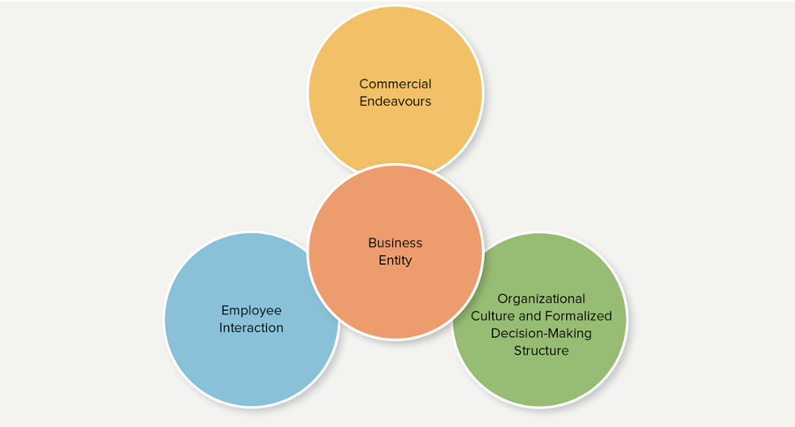

Commercial endeavours refers to the markets the organization serves, the products and services it offers, and the needs it professes to meet in the marketplace. It reflects the results of understanding the demand/supply relationships that exist in the marketplace at large, as well as within the customer segments it chooses to pursue. It also, as part of its ongoing assessment process, recognizes the capacities and capabilities of competitors within such selected markets to deliver products/services to similar buyers. Understanding this relationship, coupled with an understanding of the cost requirements needed to produce goods and services, along with the price sensitivities of targeted customers, is what enables the creation of a business model—the successful execution of which ideally results in delivering a profitable outcome to the organization.
Employee interaction refers to the value-creating skills that an organization’s employees bring to the marketplace. The success of many businesses lies with the specialized skills that exist within its labour force. The leveraging of these skills in the production of goods and/or the delivery of services is what enables a business to create value and enables transactions to occur that will allow the firm to make a profit. A great way of understanding the importance of the talent (people) component of an organization is the viewpoint expressed via the following statement: A successful strategy results from 5% thinking and 95% execution, and successful execution of a company’s strategy is the result of the leveraging of 5% technical competencies and 95% people capabilities.
Organizational efficiency and structure is a reflection of the complexities of the business activities that circulate within an organization. It is reflective of the development of the infrastructure (underlying business system) and its related culture, which an organization creates, and the transaction processes that it develops to service the marketplace it targets. These three characteristics, when assessed jointly, result in a macro-level understanding of a business entity whose objective is the design, production, distribution, and communication of goods and services that are sought after by the marketplace and valued by the customers being targeted.

2. What are the major components of a business model? How are the two parts of a business model (company-centric and market-centric) interrelated?

Business models can be best visualized as the underlying operational platform or structure a business uses to position its approach to a given market and thereby to generate its revenue and, most importantly, derive its profit.

The business model has two primary parts: the company-centric side and the market-centric side. Both of these parts hold the major components of the business model.

The company-centric side (or business system) reflects the underlying mechanics as to how our business is structured. It comprises five key areas:
1. Activities: refer to key processes an organization undertakes in order to deliver products and services to the marketplace
2. Resources: refer to four core areas – assets, labour, capital, managerial acumen
3. Partners: refers to complementary dependencies and/or relationships we have with other organizations that are deemed essential to the design, development, and delivery of products and services to the marketplace
4. Cost Structure: the expenses that woill be incurred as a result of offering products and/or delivering services to the marketplace
5. Portfolio of Products and Services: refers to the different items, products, and/or services which a company offers for sale

The market-centric side of business model development focuses on the business’s efforts on the external factors required for success. Market-centric decisions look to draw conclusions relating to properly assessing potential market opportunities in order to determine where and how we want to compete. This means focusing our analysis on the following areas:
1. Available Customer Segments and Opportunity Assessment: recognizing that business cannot be all things to all people, businesses need to assess what customer segments will most likely respond to their efforts
2. Positioning: refers to the ability to develop a unique, credible, sustainable, and valued place in the minds of customers for brands, products, and/or services
3. Value Proposition Development: formulating the statement that summarizes to whom a product or service is geared toward and the benefits the purchaser will realize as a result of using the product or service
4. Revenue Model Development: creating the relationship between the prices organizations are able to charge for their services, the volume of purchases they are able to generate, and the profitability derived from such activity

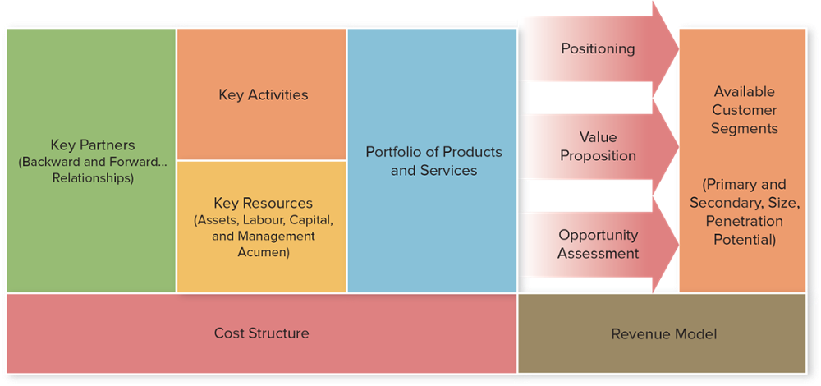

Business models are the unique manner and structure by which we conduct business on a day-to-day basis, and reflect conscious decisions relating to resource deployment in route to developing revenue and driving profit. No two companies are alike, and it is their deployment of assets and capabilities, via their business model, that determines which companies are more profitable.

3. What are the overarching responsibilities of managers? Is any single responsibility more important than the others?

The role of the business owner or top-level management team is to anticipate, recognize, and act upon opportunities that then drive the creation of products and/or delivery of services believed to offer solutions to problems in a unique, important, and valued (meaningful) way to a targeted customer or customers. This leveraging of a market opportunity is realized via the efficient and effective execution of the business model the management team creates, and the deployment of the productive resources the organization possesses.

Managers must develop a strategy geared toward taking advantage of market opportunities and recognizing the required capabilities, competencies, and capacity the company must possess in order to successfully execute such a strategy. Once strategic direction is determined, it is the role of the management team to develop and execute the business model to achieve the desired objectives. As shown in Figure 1.7 below, the effectiveness of strategic development and tactical execution results in business growth and profitability.

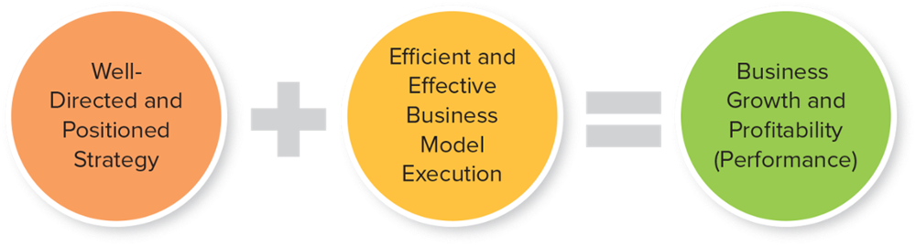

Typically, no single responsibility is deemed more important than any other. All responsibilities are part of the business entity and must be handled appropriately to ensure that the organization operates at optimal efficiency. However, a well-directed and positioned strategy naturally comes before efficient and effective execution because strategy is the blueprint of the operation business model.

4. What are the three fundamental objective managers need to consider as they manage the ongoing evolution of a business entity? What importance does each bring to the resource allocation process?

The three fundamental objectives managers need to consider as they manage the ongoing evolution of a business entity are short-term profit, long-term growth and profitability, and corporate social responsibility.

Short-term profit is necessary for the resource allocation process because it allows organizations to pay their bills and reinvest in the future. Making a profit on a monthly, quarterly, and annual basis is fundamental to ensuring the immediate survival of the firm.

Long-term growth and profitability is necessary for resource allocation because it ensures that the organization remains healthy and continues to grow over time. Businesses recognize that the demand for the products and services they currently offer will change, and may even disappear over time. Businesses must look beyond their current success and seek new opportunities for future growth to guarantee ongoing profitability.

Social and environmental responsibility (branded as Corporate Social Responsibility) is becoming an increasingly important part of the business decision-making process. Consumers worldwide are encouraging that businesses operate and act in a manner that demonstrates social responsibility with respect to product development, resource consumption, and operating processes. Engaging in these pro-social behaviours better enable businesses to acquire and retain revenue-generating customers.

5. Why is it important for managers to think beyond the immediate horizon? How does doing so change the emphasis among managerial responsibilities?

Similar to the question above, managers need to think beyond the immediate horizon because short-term profits are only one piece of the organizational success puzzle. While immediate profits are necessary to ensure the lights of the business are on, what is proven to be successful today may not be successful tomorrow. Therefore, managers must be able to look beyond the next round of company reports in order to generate long-term growth and profitability. Thinking in this way, across multiple horizons, will influence managers to invest in and nurture new growth opportunities that are critical to creating a sustainable trajectory for an organization.

6. Define what is meant by a business planning cycle. What are its key components?

The business planning cycle outlines the focus and methodology for setting the business model in motion. Ideally, this plan would be built around the leveraging of a competitive advantage, a key component of the cycle. A company has a competitive advantage when it possesses capabilities that enable the company to perform critical activities better than its rivals. Establishing a competitive advantage is essential to attracting customers and generating revenue/profit, which is then reinvested back into the company to grow. This process of strategizing, executing on a competitive advantage, and reinvesting profits is the essence of the business cycle.

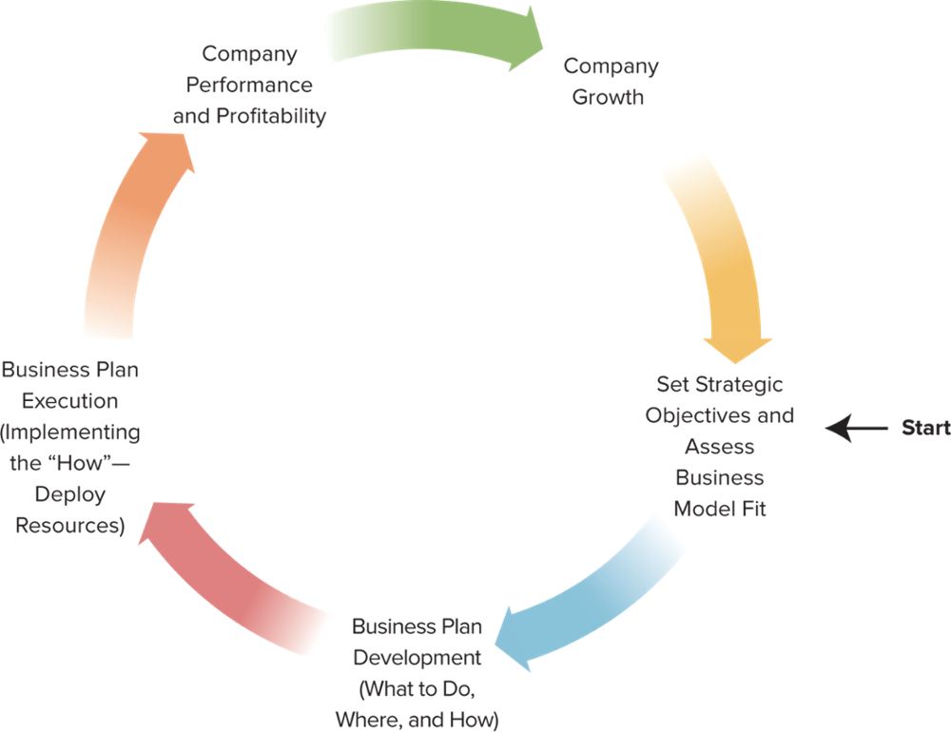

Businesses grow by executing a series of planning cycles over time. Each planning cycle is designed to direct the positioning of the company within the marketplace, orchestrate the creation of a business plan that will achieve the objectives formulated for the planning period, ensure linkage with the vision and mission of the organization, and implement the required adjustments to the business model that will ensure the plan is executed in a fashion that leads to growth and profitability. The management team must then allocate the resources and leverage the company’s capabilities in a manner that ensures the tactics designed to achieve the objectives identified actually work and produce the desired results. Finally, the management team needs to assess the success of the company in achieving the desired objectives, and determine adjustments required in order to further grow the company via future planning cycles.

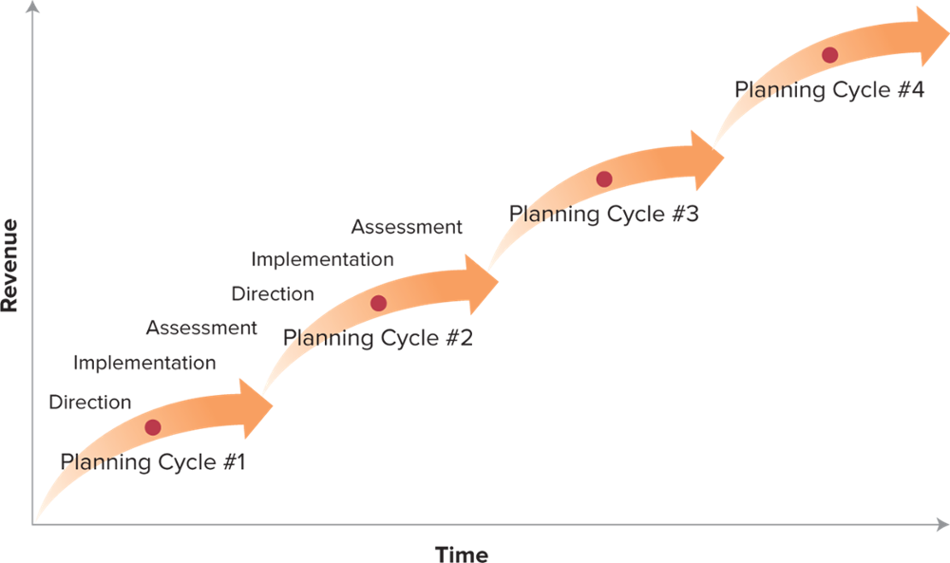

7. What is meant by the term “visionary leadership”?

Visionary leadership is all about inspiring your workforce (talent) to pursue a shared goal beyond ordinary expectations. It is about creating a clear statement as to the direction in which the organization is heading, and then creating a culture within the company that encourages and supports employees in a way where they come motivated to achieve the organization’s vision because they fully identify with it, find it meaningful, and believe that the company has the competencies, capabilities, and capacity to achieve it.

Visionary leadership is essential to the success of an organization because visionary leaders understand the driving forces that will influence market direction going forward, as well as the constraining forces that must be overcome in pursuit of the identified vision.

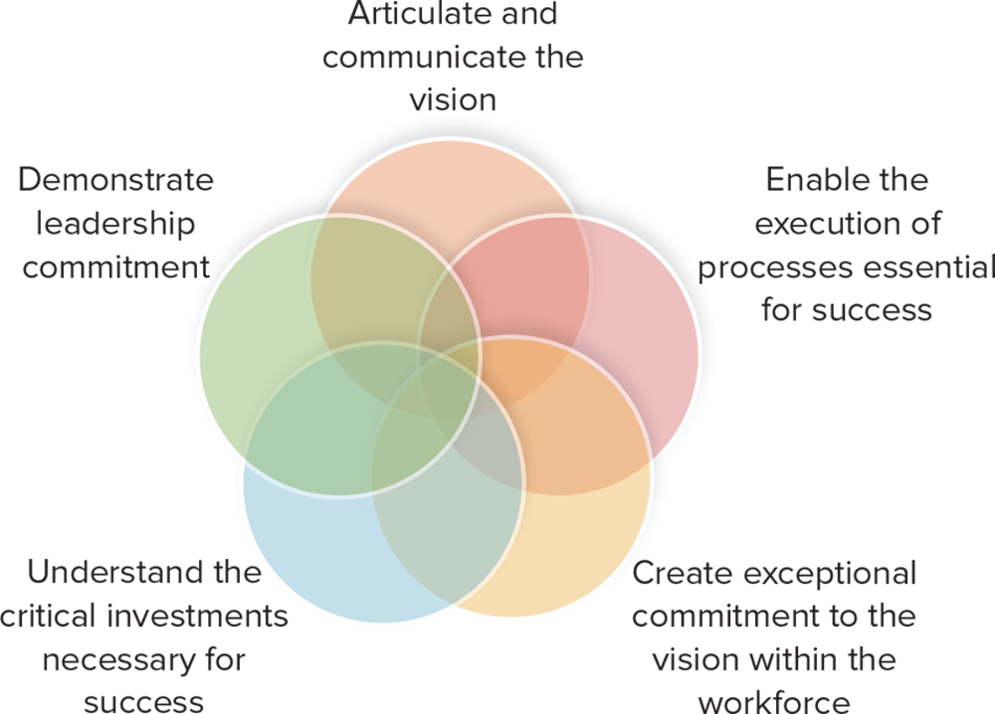

Visionary leaders understand that vision enables strategy, which provides the guidelines for the tactics and activities to be implemented within the business model. In addition, they are able to communicate the key metrics to be used to measure the success of the organization as it pursues the identified vision.

8. Provide an overview of the relationship between business strategy and business model development, and the importance of successfully executing both in order for a business to achieve its identified objectives.

Strategy is the development of plans and decisions that will guide the direction of the firm and its long-term performance. Strategy focuses on the vision of the firm and the opportunity it believes exists in the marketplace. It also checks that the life expectancy of the product or service is long enough to ensure that the initial investment can be recovered and that the firm can make a profit. Finally, strategy development assesses whether the firm has the competencies and resources to compete in this targeted market.

Tactics are the immediate term actions that a firm executes to meet the short-term objectives set forth in the current planning cycle. Tactics can be thought of as the action items a firm undertakes to ensure that it is successful in achieving its strategic objectives. Tactics could involve the expenditure of money for new equipment, the hiring of new staff with specialized skills, or the manufacturing processes undertaken to develop a product or service.

To successfully grow a company, the management team has to be successful in both planning strategy and executing tactics. Strategically, managers need to understand where the market is going and how their products and services will fit into the market and meet customer needs. Tactically, they need to ensure that the right product reaches the right customer at the right time, and at the right place for the right price.

It is important to remember that neither strategy or tactical execution are static, they are in constant flux. The last square in the figure above demonstrates that the business decision-making model must be constantly evaluated in order to stay current and ensure long-term growth and profitability.

9. What is the difference between profit and profitability? How are the two interrelated?

Profit is strictly the “bottom line” results that an organization has realized for a given period of time. In simple terms, Total Revenue – Total Expenses = Profit. Think of profit of a snapshot of past performance – essentially a number that depicts how much money the organization has brought in after operating costs, taxes, and other miscellaneous fees are deducted.

Profitability corresponds to the efficiency and effectiveness of an organization to use its assets and its capital to generate profits for the organization over a period of time. It measures how well a company is using its resources over a specific period of time to generate earnings relative to its competitors. Profitability analysis takes into consideration such factors as return on the capital invested, return on equity, the financial leverage the organization undertook to finance its assets and operations, the level of pre-tax income it earned, and so on. Profitability analysis is generally assessed over a period of time so that efficiency and effectiveness results, as noted above, can be compared on a period-over-period basis. This allows one to get an idea of how profitable a company is currently and how the potential for profit in the future.

The two concepts are interrelated because they go hand-in-hand. Profitability indicates how much profit can be earned over time.

Case For Discussion – Cruiser Laptops Inc.

This case discussion asks students to assess how a specific factor (i.e. price) became such an important factor in the customer decision-making process, and given this, what changes to the current business model need to be made if Cruiser Laptops Inc. is to remain competitive and profitable.

- What does the trend of ever-reducing prices in the laptop industry imply about the way Windows-based operating system manufacturers have been positioning their products to customers? What have they failed to do? The trend implies that all laptop using the Windows operating system are positioning themselves to essentially be the same. What these manufactures have failed to do is establish a competitive advantage that differentiates them from the rest of the pack. Now, whenever an individual is looking for a new Windows laptop, they will immediately look for the lowest priced machine.

- What sort of things must Cruiser Laptops Inc. do to be successful if they position themselves as a premium-price laptop manufacturer? How would this impact the current business model? They must justify their premium pricing with a slew of new features or value proposition development that results in a changed perception of their product. With operating margins already thin, adding new features could be a real challenge because it will completely reconfigure Cruiser Laptops Inc. manufacturing operations (company-centric side of the model) e.g. the sourcing of parts, hiring of new skilled labour, etc. It will also reconfigure the market-centric side of the model because Cruiser Laptops Inc. will be selling to an entirely new and unfamiliar market segment. This shift will require a new value proposition development that will take time to develop.

- What other options does Cruiser Laptops Inc. have? What must Sylvie do in order to be successful? What does this mean for her management team in terms of where and how the current business model needs to be adjusted? If new positioning is not possible, the company should focus on the company-centric side of the model and work to reduce costs so that they can generate profits by competing at the lowest price level, or at least maintain sales volume. This will adjust the business model’s key partners, activities, resources, and products.

- What type of analysis would you conduct prior to determining a strategic direction? A profitability analysis would be essential here because it will reveal to the management team where Cruiser Laptops Inc. can improve in its effective utilization of its assets and capital. A profitability analysis will also focus on comparisons among competitors within an industry to determine which organizations are the most effective in their utilization of resources. The management team will then have a better idea of where they want to compete and how they can best achieve success. Some potential questions: Where can we reduce extraneous costs (manufacturing, marketing, shipping, sourcing, etc)? Can we initiate a strategic partnership with organizations that are key to our success? Is there a possibility of a merger or acquisition? Are there new markets we can explore? How do we improve our position given the new changes? How can we leverage our core competencies? How can we improve where we lag behind? Which competitor do we want to take market share away from? Are there future projects we can look toward that will drive future profitability?

Quiz Questions

1. Choose the definition that best describes commercial endeavours:
a) The markets an organization serves, the products and services it offers, and the needs it professes to meet in the marketplace
b) The T.V., radio, and print advertising that an organization produces
c) A joint venture with a supplier
d) Any profit-seeking initiative that a business pursues
e) None of the above

2. What are the three fundamental characteristics of a business?
a) Accounting, Marketing, and Finance
b) Commercial Endeavours, Employee Interaction, and Organizational Efficiency and Structure
c) Sales, Costs, and Profitability
d) Market Activity, Human Capital Management, and Operations Management
e) Strategy Formulation, Implementation, and Monitoring/Review

3. What are the four core fundamental resource areas of a business?
a) Assets, labour, capital, and managerial acumen
b) Land, labour, technology, and capital
c) Business model, resources, business planning cycle, and operational efficiency
d) Land, buildings, processes, and infrastructure base
e) None of the above

4. Within the business model complementary dependencies and/or relationships businesses have with other organizations and which are deemed essential to the design, development and delivery of products and services to the marketplace are known as:
a) Partners
b) Activities
c) Resources
d) Revenue opportunities
e) None of the above

5. Within an organization’s business model, expenses that will be incurred as a result of offering products and/or delivering services to the marketplace are collectively known as the firm’s:
a) Activities
b) Portfolio of products and/or services
c) Cost structure
d) Revenue model
e) None of the above

6. An organization’s revenue model focuses on the relationship between:
a) The prices which an organization charges
b) The volume of purchases the organization is able to generate
c) The profitability derived from such activity
d) All of the above
e) None of the above

7. Leadership, which inspires your workforce (talent) to pursue a shared goal, beyond ordinary expectations is referred to as:
a) Spiritual leadership
b) Visionary leadership
c) Embedded leadership
d) Reactive Leadership
e) None of the above

8. What are the 3Cs?
a) Capacity
b) Customers, Complements, and Collaborators
c) Capabilities and Competencies
d) Capacity, Capabilities, and Customers
e) A and C

9. Which of the following is NOT a stage of the Business Planning Cycle?
a) Strategy and 3C assessment
b) Company growth and reinvention
c) Business plan execution
d) Vision statement creation and goal setting
e) Company performance and profitability

10. Objectives should be:
a) Realistic, Time Constrained, Concrete, Relevant
b) Smart, Meaningful, Actionable, Collective
c) Achievable, Concentrated, Supportive, Management-driven
d) Measurable, Actionable, Specific, Controllable
e) None of the above

11. Profitability takes into account which of the following factors?
a) Return on Capital Invested
b) Return on Equity
c) Financial Leverage
d) Return on Assets
e) All of the above

12. A positioning statement should include which of the following?
a) Target market
b) Customer need
c) Demonstrating a solution to the customer need
d) Key benefits provided
e) All of the above

13. Which of the following does NOT describe strategy?
a) Guiding the direction of the firm and determining its long – term performance
b) Focusing the firm’s vision on an opportunity in the marketplace
c) Assessing whether the firm has the competencies and resources to compete in the target market
d) Reacting to a competitor’s product launch
e) All of the above describe strategy

14. Which of the following statements best describes what business is about?
a) Business is about producing and distributing goods and services
b) Business is about making profit, and increasing shareholder wealth
c) Business is about delivering value to customers in a manner that meets their wants and desires
d) Business is about managing the environmental and social impact of its actions on stakeholders
e) All of the above are effectively describe the purpose of a business

15. The word “Tactics” refers to:
a) The immediate-term actions which a firm executes in order to meet the shorter-term objectives set forth in the current planning cycle
b) The development of plans and decisions which will guide the direction of the firm and determine its long-term performance
c) The creation of a vision of the opportunity which the organization senses in the marketplace
d) The process of confirmation by which an organization believes the direction of the marketplace is certain enough to pursue its strategic intent
e) None of the above.

