End of Chapter Material

Chapter 1

**ANSWER KEY – CHAPTER 1 END OF CHAPTER MATERIAL**

**CRITICAL THINKING**

CT-1 Anthony and Cleopatra. Everything needed to answer the question “how did they die?” is contained in the following passage:

Anthony and Cleopatra are lying dead on the floor in a villa. Nearby on the floor is a broken bowl. There is no mark on either of their bodies, and they were not poisoned. With this information, determine how they died.

Solution. Suffocation. Why? Anthony and Cleopatra are fish. This fact would be observed as soon as the investigator enters the room. Fish out of water, “lying dead on the floor” would lead to suffocation as the most likely cause of death. The issue is one of assumptions. Most readers assume that Anthony and Cleopatra are people. This tends to limit the ability of the reader to “think outside the box” to derive the proper solution. The challenge is that most people make assumptions and do not even realize that an assumption is being made. For forensic accounting and fraud examination professionals, it’s critical to keep an open mind, overtly (to the extent possible) identify all assumptions and base conclusions solely on the evidence available.

CT-2 The Light Switch. A man stands at one end of a 100 meter curved hallway where he cannot see the end. Next to him are three light switches, and at the end of the hall is one incandescent light.

How many feet will the man have to walk to definitively say which light switch operates the light?

Solution. 100 meters. How do we know for sure?

Flip on switch 1 and leave it one for a minute or two, then switch it off

Flip on switch 2 and immediately walk 100 meters to the end of the hallway

If:

* The Light is On, Then Switch 2 Controls the Light;
* The Light is Off but Warm, Then Switch 1 Controls the Light;
* The Light is Off and Cold, Then Switch 3 Controls the Light

**REVIEW QUESTIONS**

1. Define fraud and identify a potentially fraudulent situation.

***Answer:*** Fraud is an intentional deception, whether by omission or co-mission, that causes its victim to suffer an economic loss and/or the perpetrator to realize a gain. Potentially fraudulent situations may include, for example:

* + Misappropriation of funds, securities, supplies, or other assets.
  + Impropriety in the handling or reporting of money or financial transactions.
  + Profiteering as a result of insider knowledge of company activities.
  + Disclosing confidential and proprietary information to outside parties.
  + Disclosing to others, securities activities engaged in or contemplated by the company.
  + Accepting or seeking anything of material value from contractors, vendors, or persons providing services/materials to the Company. Exception: Gifts less than US $50 in value.
  + Destruction, removal, or inappropriate use of records, furniture, fixtures, and equipment.

1. Differentiate between fraud and abuse.

***Answer:*** Although bothfraud and abuse involve an intentional deception that causes its victim to suffer an economic loss and/or the perpetrator to realize a gain, abuse does not rise to the level of fraud. Abuse is often a way to describe a variety of petty crimes and other counterproductive behavior, such as surfing the web while at work, coming to work late or leaving early, using sick leave when not sick, that have become common and even silently condoned in the workplace.

1. Describe the services that a forensic accountant might provide related to a marital dispute.

***Answer:***Forensic accountants may assist attorneys with assembling the financial information necessary to either bolster (if hired by the plaintiff) or undercut (if hired by the defendant) a case. This may include, for example, locating hidden marital assets or income, calculating the present value of future cash flow from retirement plans and providing testimony in the case.

1. Explain the differences between an audit, fraud examination, and forensic accounting engagement.

***Answer:*** Audits, fraud examinations, and forensic accounting engagements have six major differences:

1. Timing - Audits are conducted on a regular recurring basis while a fraud examination is nonrecurring and is only conducted on sufficient predication. A forensic accounting engagement is also nonrecurring and is only conducted after an allegation of misconduct.
2. Scope - The scope of an audit is general while the scope of a fraud examination or forensic accounting engagement is specific. Audits are a general examination of financial information for material misstatements while fraud examiners and forensic accountants are engaged to resolve a specific allegation.
3. Objective - The objective of auditing is to express an opinion on the financial statements of an organization. The objective of a fraud examination is to determine whether or not fraud has taken place and to determine who is responsible, while a forensic accounting engagement is to determine the financial impact of the allegations.
4. Nature of the relationship - Auditing is non-adversarial while fraud examination is adversarial in nature. The forensic accountant is independent.
5. Methodology - Auditing primarily entails examining financial data, while fraud examination and forensic accounting involve gathering sufficient financial and non-financial evidence to meet their objective.
6. Approach - Auditors are required to approach an audit with professional skepticism while fraud examiners and forensic accountants attempt to establish sufficient proof to meet their objective.
7. Explain the theory of the fraud triangle.

***Answer:***The fraud triangle provides an explanation for the conditions necessary for fraud to occur – perceived pressure, perceived opportunity, and rationalization.

1. List the legal elements of fraud.

***Answer:***Under common law, fraud includes four essential elements:

1. A material false statement
2. Knowledge that the statement was false when it was spoken
3. Reliance on the false statement by the victim
4. Damages resulting from the victim’s reliance on the false statement
5. Identify common fraud schemes.

***Answer:***Common fraud schemes include asset misappropriation, corruption, and false statements.

1. Give examples of non-fraud forensic and litigation advisory engagements.

***Answer:***Engagements may be criminal, civil or administrative cases that involve economic damage claims, workplace or matrimonial disputes, or asset and business valuations.

1. Describe the fraud examiner/forensic accountant’s approach to investigations.

***Answer:***Fraud examination and forensic accounting entail examining documents, reviewing records, and interviewing witnesses.

1. Explain fraud examination methodology.

***Answer:***Fraud examination involves obtaining documentary evidence, interviewing witnesses and potential suspects, writing investigative reports, testifying to findings, and assisting in the general detection and prevention of fraud.

**MULTIPLE CHOICE QUESTIONS**

1. Which of the following is ***not*** an essential element of fraud?
   1. A material false statement
   2. Knowledge that the statement was false when it was spoken
   3. Evidence that the statement was false
   4. Damages resulting from the victim’s reliance on the false statement

Answer: C. Evidence is not an essential element. Evidence supporting each element is assumed.

1. Select from the following situations the one that should ***not*** be defined as abuse:
   1. A human resources employee surfs the Internet, including searching for college friends on social media during working hours.
   2. A human resources employee calls in sick and then spends the day getting a car repaired, going to the DMV and shopping at a local retail outlet.
   3. A human resources employee surfs the Internet, including social media during working hours for information about prospective employees.
   4. A human resources employee takes their laptop home for the weekend to search for college friends on social media.

Answer: C. Because the search is “for information about prospective employees” is not an inappropriate use of company assets.

1. Which of the following is true with regard to the relative importance of interviewing?
   1. Auditors never interview clients and interviewing plays little role in auditing.
   2. In a civil litigation setting, very little interviewing is performed by attorneys through the deposition process.
   3. Interviewing is an integral part of auditing, fraud examination and forensic accounting and all such professionals should develop and refine interviewing skills.
   4. In general, auditors are provided exceptional training in interviewing skills and techniques.

Answer: C. Interviewing is an integral part of auditing, fraud examination and forensic accounting and all such professionals should develop and refine interviewing skills.

1. Which scenario is an example of larceny?
   1. Brook borrowed a company computer and didn’t intend to return it.
   2. Larry took cash from the register and replaced it with an IOU.
   3. Mary used a company vehicle without her supervisor’s permission.
   4. Daniel accepted a new car from a vendor to influence his current company to purchase additional merchandise from this vendor.

Answer: A. larceny is a “naked” theft with no effort at concealment. Answer B provide some element of concealment. Answer C doesn’t imply that the usage was for personal purposes. Answer D is more consistent with corruption.

1. The following evidence might help anti-fraud professionals understand and possibly identify which of the following types of fraud perpetrators?
   1. The perpetrator who has stolen from and been fired by two previous employers in the last 4 years.
   2. Two perpetrators who collude to steal hundreds of thousands of dollars and split the stolen cash.
   3. A financially well-off perpetrator who has been stealing from his House of Worship every week for the last 15 years.
   4. The perpetrator whose spouse is diagnosed with a rare cancer that is not covered by the employee’s health insurance but whose treatment will be very expensive and cost more than the employee earns and the employees was the only one with access to bank accounts and accounting records.

Answer: D. The evidence is pretty powerful in that the employee has a need and exclusive access to cash and an ability to cover-up any missing cash.

1. Which of the following is a true statement about fraud statistics?
   1. Position tends to have only a minor impact on the frequency of fraud but higher level personnel (e.g., managers) tend to steal lower dollar amounts.
   2. Men tend to steal more frequently than women.
   3. Large corporations tend to be the biggest victims of fraudsters in terms of frequency and dollar losses.
   4. Men and women tend to steal at the same frequency and at approximately the same dollar values.

Answer: B. Data clearly demonstrate that men are more often perpetrators.

1. Which of the following is a true statement about the detection of fraud?
   1. The combined frequency of tips and accidents in discovering fraud exceeds the combined frequency of internal and external audits.
   2. Law enforcement plays a significant role in the detection of white collar (economic) crimes.
   3. Internal controls when properly designed are almost bullet proof in terms of preventing fraud.
   4. For the purposes of understanding how fraud is discovered, whistleblower hotlines are the only method proven to detect fraud.

Answer: A. The combined frequency of tips and accidents in discovering fraud exceeds the combined frequency of internal and external audits.

1. Which of the following would likely be characterized as a forensic accounting investigation rather than a fraud examination?
   1. An employee submits unsupported damage claims to his employer, provides false documents and statements, and deposits the insurance proceeds in his bank account.
   2. A husband submits altered bank account statements to his wife’s attorney during their divorce case.
   3. A plaintiff claims that a breach of contract by a vendor resulted in a loss of business and ultimate bankruptcy.
   4. The state taxing agency has accused a state resident of filing a false tax return, claiming that income appears in their bank account but does not appear as income on their tax filings.

Answer: C. Breach of contract and bankruptcy without allegations of fraudulent conduct are normally classified as forensic accounting issues.

1. Given the elements of fraud, which element is most often associated with evidence of intent by the perpetrator?
   1. The conversion.
   2. The concealment.
   3. The act.
   4. All three elements are indicative of intent.

Answer: B. Concealment often entails an overt act to cover-up the fraud and is consistent with intent.

1. Which of the following is a true statement about fraud examination methodology?
   1. Remediation requires a critical examination of internal control weaknesses.
   2. Fraud can always be prevented.
   3. Predication is almost always discovered near the end of the investigation.
   4. Deterrence is most closely associated with making sure that perpetrators spend time in jail for their crimes.

Answer: A. One activity associated with remediation is the examination of how did this happen with an eye towards prevention of similar acts in the future.

**FRAUD CASEBOOK**

Bernie Madoff

Read the following articles or other related articles regarding the Bernie Madoff case and then answer the questions below:

Sources:

Jason Zweig, “How Bernie Madoff Made Smart Folks Look Dumb,” Wall Street Journal, December 13, 2008

Zachary Goldfarb, “SEC Broadens Its Probe of Failures in Madoff Case,” Washington Post, January 6, 2009.

Summary and Solution to Discussion Questions:

Bernard Madoff, 70, ran an investment fund that serviced pensions, institutional investors, endowments and the rich and famous. As it turns out, it was all a Ponzi scheme, where in December 2008, according to the SEC, Madoff admitted to stealing $50 billion. How does $50 billion just vanish?

The firm was Bernard L. Madoff Investment Securities LLC and it reported steady monthly returns of approximately 1% for nearly two decades. When someone is successful, no one wants to look too closely. Given that Madoff had the trust of wealthy persons, universities, charities and other investment fund managers, due diligence was not performed. For decades, Madoff was well known on Wall Street and had an impeccable reputation for success. In addition, he emphasized secrecy and exclusivity. Investors were more afraid of not being invited to invest than they were about the risk of losing money. With this country club mentality, his activities were not very well scrutinized.

Even when allegations were made and opportunities to examine Madoff’s LLC arose, those responsible failed to unveil what was really going on. The SEC and lawmakers are trying to understand these failures. While some of the $50 billion may ultimately be found, most likely investors will get little money when it’s all said and done.

Short Answer Questions

1. What type of fraud scheme did Bernie Madoff commit?

2. What was Bernie Madoff’s monthly average return to his clients?

3. How long did this monthly average return last?

4. Describe the demographics of Bernie Madoff’s customer base.

5. How was Madoff’s scheme discovered?

6. Did anyone attempt to inform the regulators about Madoff’s scheme? If so, who?

### Answers to Short Answer Questions

1. Ponzi scheme
2. 1% per month
3. Nearly two decades
4. Wealthy individuals, universities, charities and other investment fund managers
5. Auditor, Securities and Exchange Commission (SEC)
6. Harry Markopolos

Discussion Questions

1. In general, would you define Bernie Madoff’s clients as sophisticated investors or naive? Why?

2. Whether you described Bernie Madoff’s customers as naïve or sophisticated, what trait(s) allowed his clients to become victims?

3. Why wasn’t Bernie Madoff’s scheme caught earlier?

**Answers to Discussion Questions** can be found within the Fraud Casebook Summary.

**BRIEF CASES**

1. Assume that an organization maintains and uses one checking account. Further assume that a representative of the bank where the checking account is located has alerted law enforcement that the checking account has deposit activity that has several cash deposits that are just below $10,000. As readers will learn in later chapters, the U.S. Treasury Department has reporting requirements for financial institutions that require that cash transactions of $10,000 or more be reported to the U.S. Federal Government on a Currency Transaction Report (CTR) form. CTRs are analyzed using big data and data analytics techniques to identify potential money launderers.

Case Discussion: Consider the following questions:

1. If the deposits observed by the bank representative are less than $10,000, why is the bank representative concerned?

Solution: Perpetrators knowledgeable about the Federal CTR cut-off of $10,000 could “structure” deposits just below the reporting threshold in an attempt to conceal nefarious cash-based activities.

1. Assuming that an examination of this issue is launched by law enforcement, what is the scope of the examination?

Solution: Student should focus in on the fact that this is a relatively narrow issue. The textbook reviews differences between an audit, fraud and forensic accounting engagements. Students should identify that this is a forensic accounting engagement (i.e., the intersection between accounting and the law). The scope centers on deposit activity, particularly determining if a pattern of deposit amounts just below $10,000 exists.

1. Assuming that an examination of this issue is launched by law enforcement, should a forensic accountant or fraud examiner subpoena all bank and company records for the past five years? Why or why not?

Solution: No. The students should work within the scope of the engagement. As such, that would necessitate an examination of recent bank statements to determine if the deposit activity is consistent with “structuring” of deposits just below the $10,000 reporting threshold. Once the bank statements from several months were collected, those statements could be examined to see if a pattern of structured deposits exists (several or numerous deposits just below the $10,000 reporting limit). Once a pattern of structuring is identified, the evidentiary request would expand to see when the structuring seems to have begun and end. From there, investigators would start to collect additional evidence consistent with the act, concealment (structuring is inherently part of concealment) and conversion (benefit), answering the questions of who, what, when, where and how. As such, arbitrarily subpoenaing five years of statements is not appropriate at the outset.

1. What would be the first step in an examination of this issue?

Solution: Confirm that evidence is supportive of the act: structuring deposits just below the $10,000 threshold. See also the answer provided in part c.

2. Assume that a company receives a tip that the company is being “ripped off.” The tip alleges that a company employee with checking account and recordkeeping authority is accepting and paying invoices from a contractor for work that is not being performed and is not needed.

Case Discussion: Answer the following questions:

1. What is the scope of work that a forensic accountant or fraud examiner would consider at this point in time? Why?

Solution: The scope should focus on, and be limited to, the collection and analysis of evidence associated with the allegation: inappropriate expense disbursements.

1. How does this scope of work differ from an (i) audit of the victim company’s financial statements or (ii) an engagement to complete the company’s current year’s tax return?

Solution: (i) The scope of the allegations is much more restricted and limited in comparison to an audit. The audit of the financial statements is about fairness of the reporting of the financial statements (balance sheet, income statement and statement of cash flows). This is a much broader scope than the allegations associated with inappropriate expense disbursements. For example, at this point in time, the payroll disbursements and tax expense estimates are not within the scope of allegations. (ii) *The AICPA’s Statements on Standards for Tax Services (SSTSs Standards No. 3 and 4)* and the *IRS’ Circular 230 Tax Professionals* identify the tax preparers’ responsibility with regard to such activities. The responsibility are different than those associated with the narrow allegation of inappropriate expense disbursements. In general, tax preparers’ are not required to search for malfeasance as long as they have no reason to believe that the books and records provided by the client to prepare tax returns have been tainted.

1. Would the examination of the alleged “rip off” entail more or less work than an audit of the financial statements?

Solution: Unknown. While an audit is broader in scope, the audit standard is “reasonable assurance that the financial statements are free from material misstatement whether cause be error or fraud.” If the allegations of malfeasance do not meet the fraud examination threshold of predication, no further work would be required and the examination would require less effort than an audit. However, if the allegation of inappropriate expense disbursements is “the tip of the iceberg” and lots of malfeasance is occurring, the amount of work associated with the fraud examination might significantly exceed that of an audit.

**MAJOR CASE INVESTIGATION (MCI) – Johnsons Real Estate**

Johnsons Real Estate is a major case investigation. Readers will complete one major case investigation (MCI) throughout this text; at the end of each chapter, relevant case evidence will be provided through the instructor and an assignment related to the case investigation will be described. Across the chapters of this text, assuming that one completes each chapter’s assignment, the reader will complete the entire case investigation. Alternatively stated, a major case investigation and its relevant evidence has been broken into pieces and each piece or several pieces are examined at the end of each chapter; by the end of the text, the investigation will have been completed and a report written.

The purpose of the major case investigation is to provide the reader with experience in performing basic investigative tasks and analysis. The project will involve analyzing real-world, but simulated, case information, including business records to determine if fraud or a financial crime has occurred, and if so, who did it, what was done, how, when (during what date / time period), and where (e.g., what locations or organizations were involved). Students follow investigative processes used in real cases by conducting analytical reviews, soliciting information from clients, and reporting suspicious activity for a fictitious client company.

Chapter 1 MCI Introduction – Johnsons Real Estate

James Johnson is the broker and owner of Johnson Real Estate, a real estate sales organization in Morgantown, West Virginia. Normally, Johnson hires a local accounting firm on an annual basis to audit the organization’s financial records. With the business in a state of rapid growth, Johnson has been preoccupied and has forgone the audit for the last three years. Instead, his wife, Ashley Johnson, has exercised her somewhat rusty college accounting skills to pull the data needed for tax professionals to prepare the tax returns. In prior year, Ms. Johnson observed no issues with the records.

During the current year’s annual reconciliation of accounts, Ashley discovered discrepancies between the commission receipts from real estate closing records and the actual bank deposits. Ashley also noted that despite assurances from her husband that business has been good, the checking account balance has continued to decline and the company’s bank account fell into the red (a negative number) in December, and the company bounced a few checks during the month. Ashley also noted some unusual expenditures (seemingly non-business related expenses) in the company accounts that she was not aware of; such expenditures were not observed in prior years.

Ashley Johnson promptly but quietly filed a report with the local prosecutor, a long-time family friend and requested a thorough investigation. As a result, the prosecutor’s office has contracted a regional accounting firm to perform the financial examination.

The assignment includes working with prosecutors, special agents, law enforcement, and the complainant (Ashley Johnson). The accounting firm’s managing partner has stressed the following points:

* The prosecutor’s office has assigned special agents (SA) from the Task Force on White Collar Crime to conduct an investigation. Ashley Johnson will pay all fees for this investigation. If criminal charges are found to be supported, the prosecutor’s office will take the case forward.
* It is extremely difficult to schedule time with the Johnson’s:
  + James Johnson is politically well connected in the community and difficult to contact due to the nature of his business. Also, given his wife’s concerns, he will not be contacted directly.
  + Ashley Johnson is a practicing surgeon at a local hospital.
  + The couple has four children.
* Johnson Real Estate is a “small business” and does not employ staff accountants.
* Last month a fire at the real estate office destroyed the financial records, both paper and electronic.

In addition to compiling questions and information requests for the Johnson meeting, documentation of the team’s working processes and discussions is to be prepared and maintained throughout the course of the case as working papers.

Assignment:

Develop a preliminary examination plan to investigate the issues described in the fact scenario:

1. Consider the various issues outlined above and think critically about how you might approach the examination.
2. Brainstorm the case issues identified and start to generate a series of questions that you, as the investigator, must answer to proceed with the investigation and “solve the case.”
3. Rank order the issues and related questions.
4. Develop a data request that describes the evidentiary material required to proceed with the investigation. The data request lists physical and/or electronic evidence that might be helpful. Recall that as a forensic accountant and fraud examiner that “numbers” are your bailiwick. As such, evidence (data) could be physical or virtual, and examples might include financial numbers, financial documents, statements, invoices, cancelled checks, dates, times, contracts, databases, non-financial metrics, etc. Because of the fire at Johnson’s Real Estate, where would you find these records? (Note: The prosecutor has subpoena power to solicit evidence from 3rd party sources.)
5. What evidence is required to examine the issue or answer the question?
6. Submission to instructor: On 1-page, prioritize your list of issues / questions and associated data request. The submission should be in table format: column 1 – issue/question, column 2 – data request, column 3 – time period, column 4 – purpose of data request. Each row of the table should be a separate issue/question.

Note: Academic cases are simulated and students may not receive all data requested.

Solution.

The student’s submission should include the following:



Students may identify additional issues, questions and data requests that are relevant. Additional issues, questions and data requests not outlined above should be examined to be sure that they are within the scope of the two allegations: (i) missing deposits and (ii) inappropriate cash disbursements.



IDEA Exercises

This assignment assumes that the instructor and students have downloaded and opened the student version of IDEA.

As of the time of this writing, the web address of the IDEA Academic Partnership is the follow:

<https://www.casewareanalytics.com/idea-academic-partnership>



Professors interested in incorporating IDEA into the classroom may locate this information from IDEA directly.

IDEA Case background**.** The overall objective of the following assignments is to complete a forensic accounting / fraud examination of the payroll records related to contractors for the period January 1, 2018 through June 30, 2019. Fairmont Legal Services provides “temporary labor” services to support in-house legal council. Lawyers, employed by Fairmont, are located in the United States, Canada, England and Germany. The company started in 2017.

Fairmont Legal Services has the following accounting and payroll personnel.

* The accounting controller is Jennifer Gally and she manages the payroll master file.
* The payroll manager is Christine Alexander.
* Ms. Alexander gets payroll assistance from a general accounting clerk, Mary Perez. Ms. Perez manages the general ledger and complete almost all reconciliations.
* The accounting department has one other general accountant with no payroll duties, responsibilities nor authority, Carrie Rutten. Ms. Rutten is primarily in charge of the accounts payable, including disbursements, and accounts receivables, including collections, and well as involvement in the monthly general ledger closing and financial statement preparation.

Each week or upon completion of an assignment for a client, the contract laborers (attorneys) are paid; some some payroll disbursements are made during weekdays other than Fridays. Legal service employees who claim 80 or more hours for a payroll period require the approval of the controller prior to payment. The attorneys are treated as employees and their payroll check can be cut on any day of the week, except Saturday and Sunday. To ensure adequate supervision, review and approval of payroll processing and disbursement, Fairmont strictly requires that payroll processing occur only on Monday-Friday. FICA (social security) and Medicare are withheld from employee paychecks. The company also enrolls all employees in a 401K retirement plan. Employees can contribute up to 6% of their salary. Since company inception, only one attorney has terminated, Theresa Angelina. Ms. Theresa was one of Fairmont’s first employees and a former long-time roommate of the payroll manager.

The company also incurs payroll related (company) expenses in terms of FICA (6.2%), Medicare (1.45%) and a 6% contribution to the 401K plan (whether the employee contributes or not).

Rates paid to attorney employees range from $65 per hour to a maximum of $125 per hour with pay rates of $65, $80, $100 or $125 per hour. Client mark-up is 127.3%, including employer benefit costs.

As an example, a $65 hourly rate, plus employee expenses of 13.65 % for FICA – 6.2%, Medicare – 1.45% and 401K – 6% is a total cost to Fairmont of $73.87; the client is charged $147.74; thus, the mark-up on the base rate of $65 is 127.3% (147.74 / 65 = 2.273 minus 1 = 1.273 or 127.3%).

The company runs two payrolls, one for attorney employees who provide labor services to clients. All administrative personnel, including accounting personnel are paid as part of the administrative payroll. When payroll is disbursed, each disbursement has an ordered unique identifier called “Record.”

Known related parties: Christine Alexander has a sister who works for Fairmont as a contract lawyer, Helene Earls. Ms. Earls resides in Germany.

An examination of client profitability indicates that all clients have been billed with the appropriate mark-up. This analysis was completed on each client. Recently, two clients have complained that the costs of their services are over-budget: clients 10002 and 10008. These complaints are being handled by the sales manager and CEO and the clients seem to be very satisfied with the quality of services provided.

Assignment and Skill Summary

|  |  |  |
| --- | --- | --- |
| Chapter | Description | IDEA Skills |
| 1 | Importing data and ensuring that the file imports correctly | Creating a Project  Import a File |
| 2 | Do any accounting or payroll personnel or related parties appear on the contractor payroll? | Summarizing Data  Export a File |
| 3 | Is Fairmont in compliance with Federal withholding requirements for FICA and Medicare? | Extract: Direct  Equation Editor  Export a File |
| 4 | Is Fairmont in compliance with company policy that requires explicit approval of 80 hours or more? | Extract: Direct  Equation Editor  Sorting Data (column) |
| 5 | Does Fairmont have any duplicate payroll records? | Duplicate Key |
| 6 | Does Fairmont have any payroll processing on the weekends? | Field Statistics  Using hyper-links |
| 7 | Does Fairmont have any contactor personnel whose are being paid but are not on the payroll master file? | Import a File  Sorting Using Data-Sort  Join |
| 8 | Does Fairmont have any contactor personnel whose have terminated but are being paid through payroll (e.g., ghost employee)? | Sorting Data (column)  Extract: Key Value |
| 9 | Does Fairmont have any personnel whose last name is similar? | Summarization  Fuzzy Match  Using hyper-links |
| 10 | Is Fairmont in compliance with their payroll rates schedule: $65, $80, $100 and $125? | Summarization |
| 11 | Does the Fairmont payroll system’s company expense file match to its payroll disbursements file? | Import a File  Join |
| 12 | Does the payroll disbursements file being analyzed appear to have all of the payroll records disbursed during the period 1/3/2018 to June 28, 2019? | Gap Detection |
| 13 | The HR (human resources) department would like to identify all employees who are not withholding the maximum savings amount for the 401K retirement plan of 6%. | Virtual Data  Equation Editor  Extract: Direct  Field Statistics |
| 14 | Do the payroll hours comply with Benford’s Law? | Benford’s Law |
| 15 | Summarize forensic accounting concerns that require follow-up examination | n/a |
| 16 | Write a report | n/a |

Assignment 1

Creating a Project and Importing a File

The first step is to create a project.

1. Open IDEA
2. Click on “Create”
3. Type in the name of the project. For the assignments associated with this text, we have selected “FAFE Text Assignments” for the project name.
4. Click “OK”

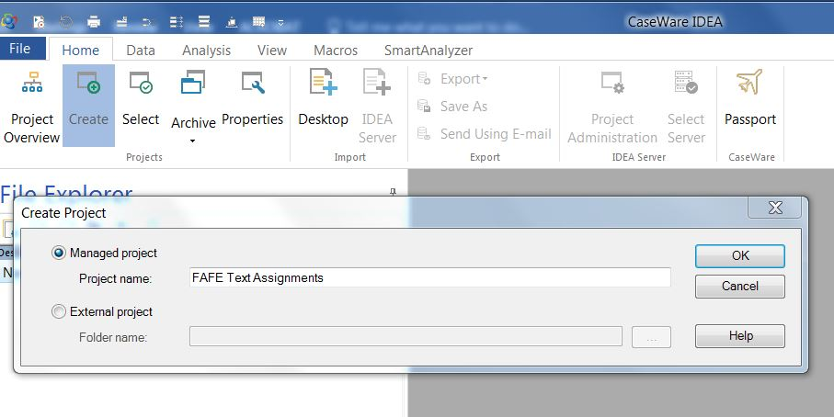

The second step is to import data.

First, import the Excel Payroll File

1. Click on “Desktop” (red box).
2. Click on “Microsoft Excel” and locate the file “Payroll for Contractors – Employee File” in the File Name area (blue oval)

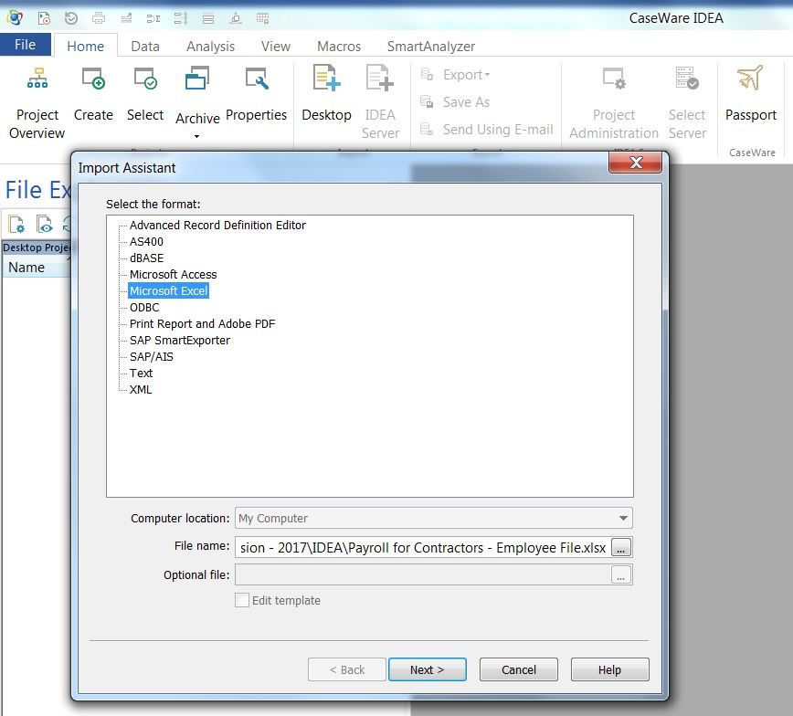

1. Click on “first row is field names” box
2. Click on “Next”
3. Click “OK”

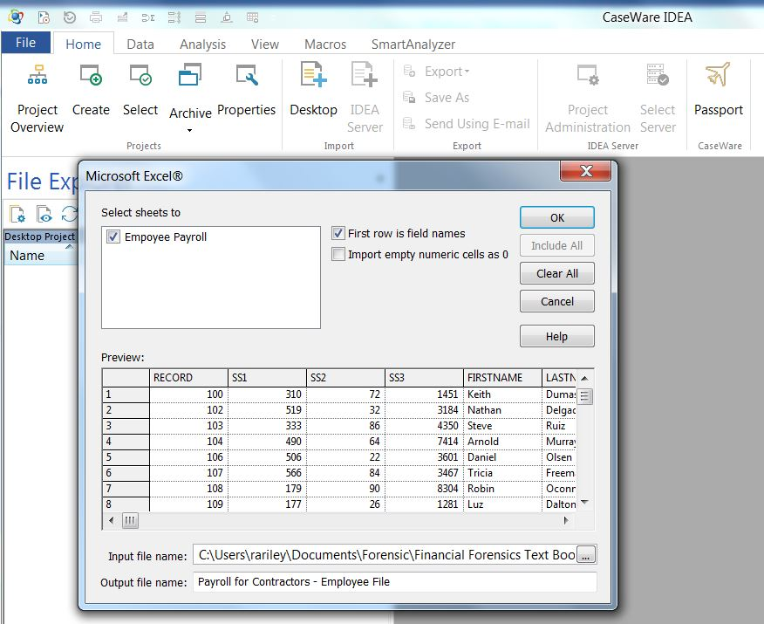

The file should have 986 records. (The importance of ensuring that data imports are complete cannot be over-emphasized).



Tableau Exercises

This assignment assumes that the instructor and students have downloaded and opened the academic version of Tableau.

As of the time of this writing, the web address of the Tableau Academic Programs is the following:

<https://www.tableau.com/academic>



Professors interested in incorporating Tableau into the classroom may locate this information from Tableau directly.

Tableau Objective. The overall objective of the following assignments is to support, through communication and analysis, a forensic accounting / fraud examination of the payroll records related to contractors for the period January 1, 2018 through June 30, 2019.

Tableau Case Background. Fairmont Legal Services provides “temporary labor” services to support in-house legal counsel. Lawyers, employed by Fairmont, are located in the United States, Canada, England and Germany. The company started in late 2017, first offering services in 2018.

Fairmont Legal Services has the following accounting and payroll personnel.

* The accounting controller is Jennifer Gally and she manages the payroll master file.
* The payroll manager is Christine Alexander.
* Ms. Alexander gets payroll assistance from a general accounting clerk, Mary Perez. Ms. Perez manages the general ledger and complete almost all reconciliations.
* The accounting department has one other general accountant with no payroll duties, responsibilities nor authority, Carrie Rutten. Ms. Rutten is primarily in charge of the accounts payable, including disbursements, and accounts receivables, including collections, and well as involvement in the monthly closing.

Each week or upon completion of an assignment for a client, the contract laborers (attorneys) are paid. Legal service employees who claim 80 or more hours for a payroll period require the approval of the controller prior to payment. The attorneys are treated as employees and their payroll check can be cut on any day of the week, except Saturday and Sunday. To ensure adequate supervision, review and approval of payroll processing and disbursement, Fairmont strictly requires that payroll processing occur only on Monday-Friday. FICA (social security) and Medicare is withheld from employee paychecks. The company also enrolls all employees in a 401K retirement plan. Employees can contribute up to 6% of their salary. Only one attorney has terminated, Angelina Theresa. Ms. Theresa was one of Fairmont’s first employees and a former long-time roommate of the payroll manager.

The company also incurs payroll related (company) expenses in terms of FICA (6.2%), Medicare (1.45%) and a 6% contribution to the 401K plan (whether the employee contributes or not).

Rates paid to attorney employees range from $65 per hour to a maximum of $125 per hour with rates of $65, $80, $100 and $125 per hour. Client mark-up is 127.3%, including employer benefit costs.

As an example, a $65 hourly rate, plus employee expenses of 13.65 % for FICA – 6.2%, Medicare – 1.45% and 401K – 6% is a total cost to Fairmont of $73.87; the client is charged $147.74; thus, the mark-up on the base rate of $65 is 127.3% (147.74 / 65 = 2.273 minus 1 = 1.273 or 127.3%).

The company runs two payrolls, one for attorney employees who provide labor services to clients. All administrative personnel, including accounting personnel are paid as part of the administrative payroll. When payroll is disbursed, each disbursement has an ordered unique identifier called “Record.”

Known related parties: Christine Alexander has a sister who works for Fairmont as a contract lawyer, Helene Earls. She resides in Germany.

An examination of client profitability indicates that all clients have been billed with the appropriate mark-up. This analysis was completed on each client. Recently, two clients have complained that the costs of their services are over-budget: clients 10002 and 10008. These complaints are being handled by the sales manager and CEO and the clients seem to be very satisfied with the quality of services provided.

Assignment and Skill Summary

| Chapter | Forensic Audit Finding | Tableau Graphic Task | Tableau Skills |
| --- | --- | --- | --- |
| 1 | Not applicable (Tableau assignment set up only) | Creating a Tableau Book and Connecting a File | Creating a Tableau Book  Connecting a File |
| 2 | The forensic accounting analysis determined that two accounting personnel were identified as inappropriately receiving disbursements through the contract attorney payroll. | Which clients, if any, were invoiced for payroll disbursed to accounting personnel. | Dimensions versus Measures  Using Columns and Rows Shelfs  Creating a Bar Chart  Exclude |
| 3 | The forensic audit has determined that Fairmont is not in compliance with Federal withholding requirements for FICA and Medicare because FICA, Medicare were not withheld from employee paychecks (November 19-23, 2018). | Present this result in a manner that is easy for the CEO, Controller and Payroll Manager to see the anomaly. | Create and Name a New Sheet  Exclude  Extract Data  Date Field  “Show Me” Panel |
| 4 | The forensic audit revealed that Fairmont was not in compliance with company policy that requires explicit approval of all hours of 80 hours or more. | Create a graphic that highlights each incidence where Fairmont was not in compliance with company policy that requires explicit approval of all hours of 80 hours or more? Can the graphic highlight both the employee lacking the approval and the number of hours for each incident. | Removing Null Data  Exclude  Remove from Column Shelf  Use Marks box  Create Labels  Change Date Presentation |
| 5 | The forensic audit has revealed that Fairmont has one employee (Carrie Rutten) that has been paid twice on the same date for the exact number of hours and appear to be duplicate payroll disbursements. | Present a graphic of duplicate payroll disbursements that includes the person’s name, the dates on which duplicate payments were made and the count (number of payments on that date). | Exclude (various techniques)  Remove from Rows Shelf  Change Date Presentation  Change Measures  Change Marks |
| 6 | The forensic audit revealed that against strict company policy, several payroll disbursements were processed on Saturday. | Create a graphic that highlights Saturday payroll processing. | Changing Date Presentation  “Switch” Icon  Create Labels |
| 7 | As noted in assignment 6, the forensic audit revealed that against strict company policy, several payroll disbursements were processed on Saturday. | Create a graphic that highlights the employee whose payroll was processed on Saturday and the dates of the process. | Exclude  Change Date Presentation  Rotate Labels |
| 8 | The forensic audit has revealed a possible “ghost” employee, Theresa Angelina, who was terminated on January 4, 2019. | Present a graphic that presents the payroll disbursement amounts by date for the contact employee who has been terminated but has been paid after termination (i.e., ghost employee). | Keep Only  “Switch” Icon  Change Date Presentation  Filter  Rotate Labels |
| 9 | The forensic audit noted payroll disbursements for “two persons” named Coitty and Coitty with the same first name and address. The interesting observation is that Coitty is dated February 28, 2019 or after while Coitti are all before February 28, 2019. | Create a graphic that shows both payroll hours and gross for Coitti before February 28, 2019 and Coitty dated on or/after February 28, 2019. | Filter  “Switch” Icon  Rearrange order of Columns Shelf |
| 10 | Is Fairmont in compliance with their payroll rates schedule: $65, $80, $100 and $125? | Create a graphic to examine the payroll by rate schedule including the anticipated rates of $65, $80, $100 and $125? | “Analysis” Menu  Create Calculated Field  Convert Measures to Dimensions |
| 11 | The forensic audit showed that a general accounting clerk, Mary Perez, has company expenses for FICA (social security), Medicare and 401K, despite no hours, nor gross payroll expense. | Create a graphic of the Fairmont payroll system’s company expense that highlights general accounting clerk, Mary Perez, has company expenses for FICA (social security), Medicare and 401K, despite no hours, nor gross payroll expense. | Keep Only  Switch Icon  Remove Null Columns |
| 12 | The forensic audit has identified three accounting / payroll personnel with disbursements in the payroll system for which clients may have been inappropriately billed: Christine Alexander, Mary Perez and Carrie Rutten. The forensic audit also revealed that at least two clients appear to have been affected: 10002 and 10008. | Present preliminary total billings and total company payroll expense for clients 10002 and 10008 for each of the above employees. | Use “Analysis” Menu  Create Calculated Field  Filter  Exclude  “Show Me”  Marks  Labels  Remove Labels |
| 13 | The forensic audit has identified a ghost employee with disbursements in the payroll system for which clients may have been inappropriately billed: Theresa Angelina. The forensic audit did not reveal which clients may have been affected. | Present the total billings by client and a grand total for Theresa Angelina for the time period after termination. | Filter  Labels  Range of Dates  Analytics (Row Grand Totals) |
| 14 | Do the payroll hours comply with Benford’s Law? | Present payroll hours Benford’s Law analysis. | Create Calculated Field  Left-Most Integer  Quick Table Calculation  Analytics  Distribution Bands / Cell |
| 15 | Summarize forensic accounting concerns that require follow-up examination | n/a | n/a |
| 16 | Write a report | n/a | n/a |

Assignment 1

Creating a Tableau Book and Connecting a File

The first step is to create a Tableau Book and Connect to the data.

1. Open TABLEAU
2. Click on “Excel” under “Connect” (red oval)

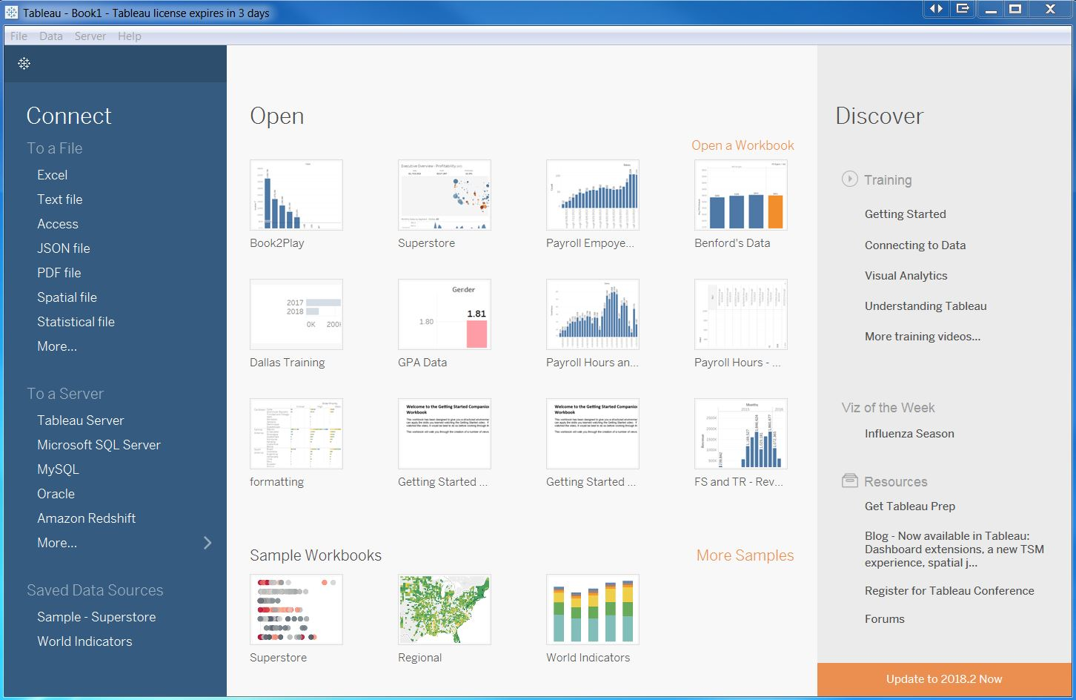

1. Locate the Excel file titled, “Fairmont Payroll and Sales”.
2. Click “OK”
3. Click on “File” and save Tableau “book” on the hard drive under a name you create (red oval)
4. Then, on the bottom, click on “Go to Worksheet” (Sheet 1) (blue square)

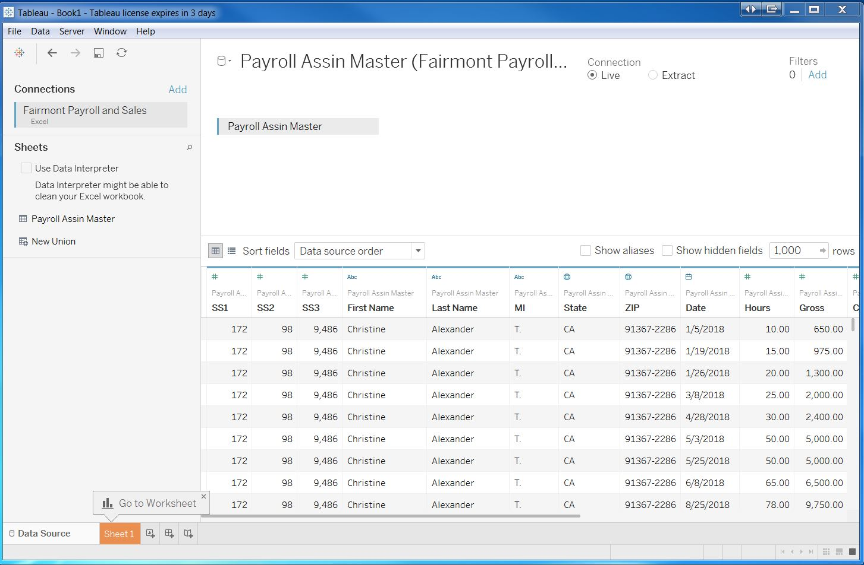

The second step is to ensure that all data connected.

1. Click on “Data” (red oval)
2. Click on the Excel filename (bottom)
3. Click on “View Data” (third line from the top)
4. The file should have 997 rows. (The importance of ensuring that data imports are complete cannot be over-emphasized). (blue square)

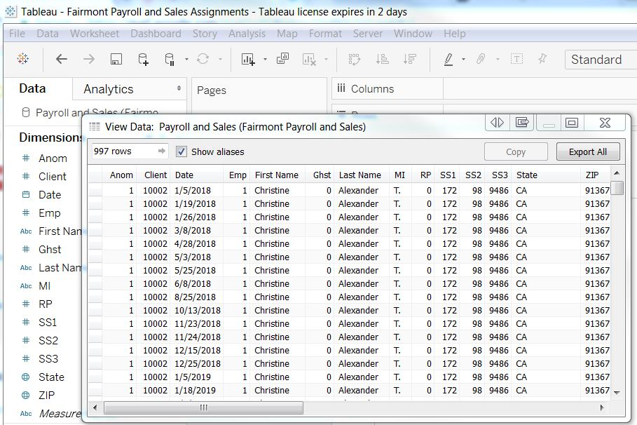

1. “X” out of “View Data”