Indicate the answer choice that best completes the statement or answers the question.

1. Which of these combinations is NOT a U.S. president and an important economic issue of his administration?
 | a. | President Carter; inflation
 | b. | President Reagan; budget deficits
 | c. | President G. H. W. Bush; budget deficits
 | d. | President Clinton; inflation

2. Macroeconomics is the study of the:
 | a. | activities of individual units of the economy.
 | b. | decision making by households and firms.
 | c. | economy as a whole.
 | d. | interaction of firms and households in the marketplace.

3. In the U.S. economy today, real gross domestic product (GDP) per person, compared with its level in 1900, is about:
 | a. | 50 percent higher.
 | b. | twice as high.
 | c. | three times as high.
 | d. | eight times as high.

4. Real gross domestic product (GDP) _____ over time, and the growth rate of real GDP _____.
 | a. | grows; fluctuates
 | b. | is steady; is steady
 | c. | grows; is steady
 | d. | is steady; fluctuates

5. In a simple model of the supply and demand for pizza, when buyers' income increases, the price of pizza _____ and the quantity purchased _____.
 | a. | increases; decreases
 | b. | increases; increases
 | c. | decreases; increases
 | d. | decreases; decreases

6. Macroeconomic models are used to explain how _____ variables influence _____ variables.
 | a. | endogenous; exogenous
 | b. | exogenous; endogenous
 | c. | microeconomic; macroeconomic
 | d. | macroeconomic; microeconomic

7. A typical trend during a recession is that:
 | a. | the unemployment rate falls.
 | b. | the popularity of the incumbent president rises.
 | c. | incomes fall.
 | d. | the inflation rate rises.

8. An assumption of _____ is more plausible for studying the short-run behavior of the economy, while an assumption of _____ is more plausible for studying the long-run, equilibrium behavior of the economy.
 | a. | deflation; inflation
 | b. | inflation; deflation
 | c. | flexible prices; sticky prices
 | d. | sticky prices; flexible prices

9. The unemployment rate:
 | a. | was zero during the 1990s in the United States.
 | b. | was zero on average between 1900 and 1950 in the United States.
 | c. | has never been zero in the United States.
 | d. | is usually zero when the economy is not in a recession or depression.

10. Which statement about economic models is TRUE?
 | a. | There is only one correct economic model.
 | b. | All economic models are based on the same assumptions.
 | c. | The purpose of economic models is to show how endogenous variables affect exogenous variables.
 | d. | Economists use different models to address different economic phenomena.

11. The assumption of continuous market clearing means that:
 | a. | sellers can sell all that they want at the going price.
 | b. | buyers can buy all that they want at the going price.
 | c. | in any given month, buyers can buy all that they want and sellers can sell all that they want at the going price.
 | d. | at any given instant, buyers can buy all that they want and sellers can sell all that they want at the going price.

12. Endogenous variables are:
 | a. | fixed at the moment they enter the model.
 | b. | determined within the model.
 | c. | the inputs of the model.
 | d. | from outside the model.

13. Macroeconomists are like scientists in that they both:
 | a. | design data and conduct controlled experiments to test their theories.
 | b. | rely on data analyzed from experiments they set up in a laboratory.
 | c. | are unlimited in their use of controlled experiments.
 | d. | collect data, develop hypotheses, and analyze the results.

14. The total income of everyone in the economy adjusted for the level of base year prices is called:
 | a. | a recession.
 | b. | an inflation.
 | c. | real gross domestic product (GDP).
 | d. | a business fluctuation.

15. A graph of the U.S. unemployment rate over the twentieth century shows:
 | a. | an overall upward trend in the unemployment rate interrupted by a large upturn in the 1930s.
 | b. | an overall downward trend in the unemployment rate interrupted by a large upturn in the 1930s.
 | c. | rates of unemployment always greater than zero with substantial variations from year to year.
 | d. | alternating periods of positive and negative rates of unemployment.

16. Two striking features of a graph of U.S. real gross domestic product (GDP) per capita over the twentieth century are the:
 | a. | overall upward trend interrupted by a large downturn due to the economic depression in the 1930s.
 | b. | nearly constant level with a large downturn in the 1930s.
 | c. | downward trend in the first half of the century followed by the upward trend in the second half.
 | d. | constant level in the first half of the century followed by the upward trend in the second half.

17. Exogenous variables are:
 | a. | determined outside the model.
 | b. | determined within the model.
 | c. | the outputs of the model.
 | d. | explained by the model.

18. In a simple model of the supply and demand for pizza, the endogenous variables are:
 | a. | the price of pizza and the price of cheese.
 | b. | aggregate income and the quantity of pizza sold.
 | c. | aggregate income and the price of cheese.
 | d. | the price of pizza and the quantity of pizza sold.

19. Important characteristics of macroeconomic models include all of these EXCEPT:
 | a. | simplifying assumptions.
 | b. | functional relationships based on randomized control trials.
 | c. | endogenous and exogenous variables.
 | d. | implicit or explicit consistency with microeconomic foundations.

20. The annual inflation rate in the United States averaged:
 | a. | nearly zero between 1900 and 1950.
 | b. | nearly zero between 1950 and 2000.
 | c. | about 10 percent between 1900 and 1950.
 | d. | about 10 percent between 1950 and 2000.

21. Variables that a model takes as given are called:
 | a. | endogenous.
 | b. | exogenous.
 | c. | market clearing.
 | d. | macroeconomic.

22. A graph of the rate of inflation in the United States over the twentieth century shows:
 | a. | an overall upward trend interrupted by a large downturn in the 1930s.
 | b. | periods of deflation mixed with positive rates of inflation before 1955 but only positive rates of inflation after 1955.
 | c. | a relatively steady, positive level throughout the century except for deflation in the 1930s.
 | d. | a constant rate of inflation in the first half of the century followed by an upward trend in the second half.

23. Recessions are periods when real gross domestic product (GDP):
 | a. | increases slowly.
 | b. | increases rapidly.
 | c. | decreases mildly.
 | d. | decreases severely.

24. Macroeconomics does NOT try to answer the question of:
 | a. | why some countries experience rapid growth.
 | b. | what is the rate of return on education.
 | c. | why some countries have high rates of inflation.
 | d. | what causes recessions and depressions.

25. When studying the short-run behavior of the economy, an assumption of _____ is more plausible, whereas when studying the long-run equilibrium behavior of an economy, an assumption of _____ is more plausible.
 | a. | inflation; unemployment
 | b. | unemployment; inflation
 | c. | flexible prices; sticky prices
 | d. | sticky prices; flexible prices

26. In the relationship expressed in functional form Y = G(K, L), Y stands for real GDP, K stands for the amount of capital in the economy, and L stands for the amount of labor in the economy. In this case G( ):
 | a. | is the growth rate of real gross domestic product (GDP) when the amount of capital and labor in the economy is fixed.
 | b. | indicates that the variables inside the parentheses are endogenous variables in the model.
 | c. | is the symbol that stands for government input into the production process.
 | d. | is the function telling how the variables in the parentheses determine real GDP.

27. The assumption of flexible prices is a more plausible assumption when applied to price changes that occur:
 | a. | from minute to minute.
 | b. | from year to year.
 | c. | in the long run.
 | d. | in the short run.

28. All of these statements about sticky prices are true EXCEPT:
 | a. | in the short run, some wages and prices are sticky.
 | b. | the sticky-price model describes the equilibrium toward which the economy slowly gravitates.
 | c. | for studying year-to-year fluctuations, most macroeconomists believe that price stickiness is a better assumption than is price flexibility.
 | d. | magazine publishers tend to change their newsstand prices only every three or four years.

29. One of President Trump's first major economic policy initiative after taking office in 2017 was a(n):
 | a. | increase in the government spending on defense.
 | b. | decrease in government spending on defense.
 | c. | increase in the taxes levied on corporations.
 | d. | decrease in taxes levied on corporations.

30. Compared with real gross domestic product (GDP) during a recession, real GDP during a depression:
 | a. | increases more rapidly.
 | b. | increases at approximately the same rate.
 | c. | decreases at approximately the same rate.
 | d. | decreases more severely.

31. In an economic model:
 | a. | exogenous variables and endogenous variables are both determined outside the model.
 | b. | endogenous variables and exogenous variables are both determined within the model.
 | c. | endogenous variables affect exogenous variables.
 | d. | exogenous variables affect endogenous variables.

32. Which is the BEST example of a flexible price?
 | a. | the price of a cup of coffee in a coffee shop
 | b. | the price of gasoline at a service station
 | c. | the price of a ticket at a movie theater
 | d. | the price of a book in a bookstore

33. The inflation rate is a measure of how fast:
 | a. | the total income of the economy is growing.
 | b. | unemployment in the economy is increasing.
 | c. | the general level of prices in the economy is rising.
 | d. | the number of jobs in the economy is expanding.

34. A measure of how fast the general level of prices is rising is called the:
 | a. | growth rate of real gross domestic product (GDP).
 | b. | inflation rate.
 | c. | unemployment rate.
 | d. | market-clearing rate.

35. Variables that a model tries to explain are called:
 | a. | endogenous.
 | b. | exogenous.
 | c. | market clearing.
 | d. | fixed.

36. The study of the economy as a whole is called:
 | a. | household economics.
 | b. | business economics.
 | c. | microeconomics.
 | d. | macroeconomics.

37. All of these EXCEPT _____ are important macroeconomic variables.
 | a. | real gross domestic product (GDP)
 | b. | the unemployment rate
 | c. | the marginal rate of substitution
 | d. | the inflation rate

38. All of these are types of macroeconomics data EXCEPT the:
 | a. | price of a computer.
 | b. | growth rate of real gross domestic product (GDP).
 | c. | inflation rate.
 | d. | unemployment rate.

39. A severe recession is called a(n):
 | a. | depression.
 | b. | deflation.
 | c. | exogenous event.
 | d. | market-clearing assumption.

40. Prior to the Covid-19 pandemic, the United States experienced its longest expansion in history with the unemployment rate in February 2020 falling to:
 | a. | 0 percent.
 | b. | 3.5 percent.
 | c. | 5 percent.
 | d. | 7.5 percent.

41. A period of falling prices is called:
 | a. | deflation.
 | b. | inflation.
 | c. | a depression.
 | d. | a recession.

42. Deflation occurs when:
 | a. | real gross domestic product (GD decreases.
 | b. | the unemployment rate decreases.
 | c. | prices fall.
 | d. | prices increase but at a slower rate.

43. In a simple model of the supply and demand for pizza, when the price of cheese increases, the price of pizza _____ and the quantity purchased _____.
 | a. | increases; increases
 | b. | decreases; increases
 | c. | decreases; decreases
 | d. | increases; decreases

44. The ability of macroeconomists to predict the future course of economic events:
 | a. | is no better than a meteorologist's ability to predict the next month's weather.
 | b. | is much better than a meteorologist's ability to predict the next month's weather.
 | c. | has gotten worse over time.
 | d. | is less precise than it was in the 1920s.

45. Macroeconomic models:
 | a. | assume that all wages and prices are sticky.
 | b. | assume that all wages and prices are flexible.
 | c. | make different assumptions to explain different aspects of the macroeconomy.
 | d. | focus primarily on the optimizing behavior of households and firms.

46. During the period between 1900 and 2000, the unemployment rate in the United States was highest in the:
 | a. | 1920s.
 | b. | 1930s.
 | c. | 1970s.
 | d. | 1980s.

47. Which statement BEST illustrates the "art," rather than the "science," of macroeconomics?
 | a. | Macroeconomic data provide the motivation for new macroeconomic theory.
 | b. | Macroeconomic relationships can be expressed using symbols and equations.
 | c. | Macroeconomists must determine which simplifying assumptions clarify our thinking and which ones mislead us.
 | d. | Graphs and charts can be used to illustrate the history of macroeconomic variables.

48. Which is the BEST example of a sticky price?
 | a. | the price of a barrel of oil
 | b. | the price of the U.S. dollar in terms of euros
 | c. | the price of a share of stock
 | d. | the price of a soda in a vending machine

49. Using a market-clearing model to analyze the labor market is _____ because wages usually change _____.
 | a. | realistic; frequently
 | b. | realistic; infrequently
 | c. | unrealistic; frequently
 | d. | unrealistic; infrequently

50. What is the difference between recession and depression in an economy? Provide an example of depression from the real world that has hit the global economy.

51. Refer to the following table, which shows the quantity of tubes of toothpaste that are demanded at different prices. Identify the price (as shown in the first column below in the table) that represents the market clearing.
Price (US$/tube) | Quantity demanded (thousands of tubes) | Quantity supplied (thousands of tubes)
20 | 5 | 20
16 | 8 | 16
13 | 12 | 12
8 | 15 | 8
5 | 17 | 5
4 | 18 | 3

52. Are the terms "market clearing" and "equilibrium" one and the same? Explain.

53. Column A below lists the names of four U.S. presidents, and Column B lists four economic events that occurred during the tenures of those U.S. presidents. Match each president to the economic event that occurred during his tenure.
Column A | Column B
1. Jimmy Carter | a. budget surplus
2. Ronald Regan | b. inflation
3. Bill Clinton | c. steep rise in mortgage defaults
4. Barack Obama | d. budget deficit

54. Do you agree with the statement "macroeconomics rests on the foundation of microeconomics"? Explain.

55. The production function for an economy can be expressed as Y = F(K,L), where Y is real GDP, K is the quantity of capital in the economy, and L is the quantity of labor in the economy.
a. | If F( ) = 100 + 3K + 9L, what is real GDP if the quantity of capital is 200 and the quantity of labor is 500?
b. | What is/are the endogenous variable(s) in this model?
c. | What is/are the exogenous variable(s) in this model?

56. Assume that the equation for demand for bread at a small bakery is Qd = 60 − 10Pb + 3Y, where Qd is the quantity of bread demanded in loaves and Y is the average income in the town in thousands of dollars.
a. | If the average income in the town is 10, state the equation for Qd in terms of Pb.
b. | Draw a graph of the demand curve with Qd on the horizontal axis and Pb on the vertical axis. Label the curve DD.

57. Why do we call macroeconomics an imperfect science? Explain.

58. Assume that the equation for demand for bread at a small bakery is Qd = 60 − 10Pb + 3Y, where Qd is the quantity of bread demanded in loaves, Pb is the price of bread in dollars per loaf, and Y is the average income in the town in thousands of dollars. Assume also that the equation for supply of bread is Qs = 30 + 20Pb − 30Pf, where Qs is the quantity supplied and Pf is the price of flour in dollars per pound. Assume finally that markets clear, so that Qd = Qs.
a. | If Y is 10 and Pf is $1, solve mathematically for equilibrium Q and Pb.
b. | If the average income in the town increases to 15, solve for the new equilibrium Q and Pb.

59. What is the difference between sticky prices and flexible prices? Explain.

60. The quantity of coffee demanded, Qd, depends on the price of coffee, Pc, and the price of tea, PT. The quantity of coffee supplied, Qs, depends on the price of coffee, Pc, and the price of electricity, PE, according to the following equation:
 | Qd = 17 − 2Pc + 10PT
 | Qs = 2 + 3Pc − 5PE
a. | If the price of tea is $1.00 and the price of electricity is $0.50, what are the equilibrium price and quantity of coffee?
b. | What is/are the endogenous variable(s) in this model?
c. | What is/are the exogenous variable(s) in this model?

61. What is an exogenous variable? Illustrate with graphs the effect of a change in the exogenous variable on a demand and supply relationship. Mark the x-axis and y-axis clearly.

62. Give two examples of macroeconomic variables and microeconomic variables.

63. Refer to the following graph and identify the years for which Country A and Country B experienced recession.
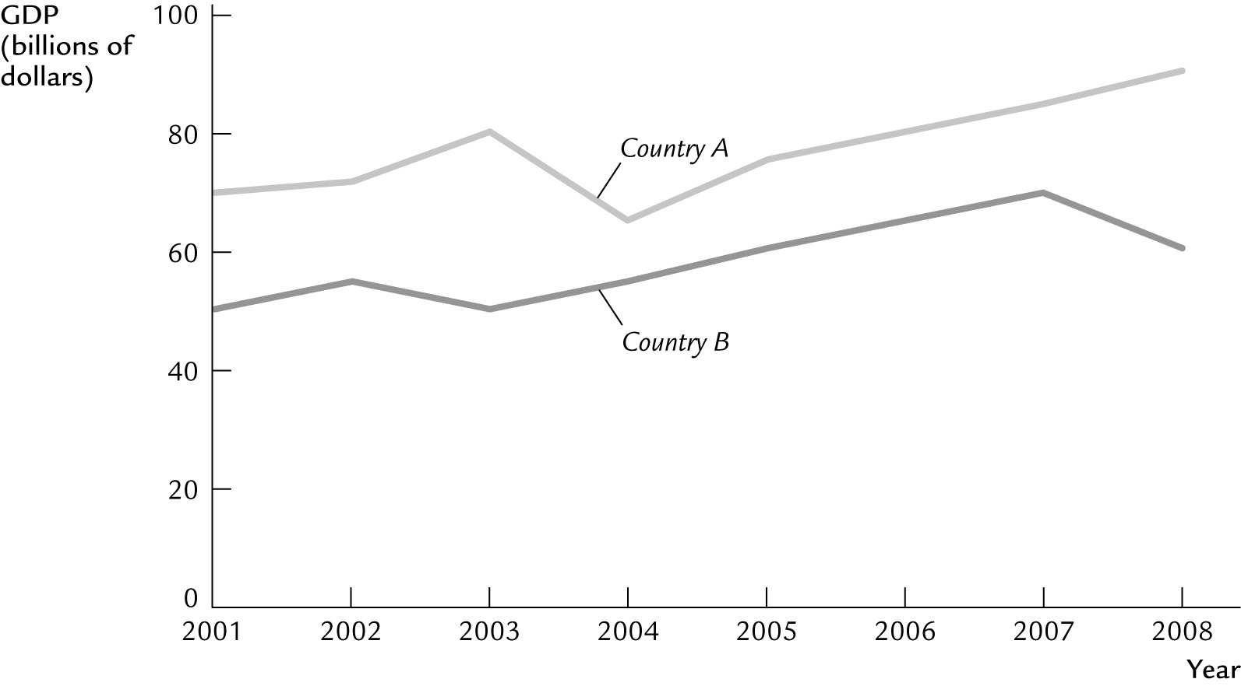

Answer Key
1. d

2. c

3. d

4. a

5. b

6. b

7. c

8. d

9. c

10. d

11. d

12. b

13. d

14. c

15. c

16. a

17. a

18. d

19. b

20. a

21. b

22. b

23. c

24. b

25. d

26. d

27. c

28. b

29. d

30. d

31. d

32. b

33. c

34. b

35. a

36. d

37. c

38. a

39. a

40. b

41. a

42. c

43. d

44. a

45. c

46. b

47. c

48. d

49. d

50. When there is a mild fall in the real gross domestic product (GDP) of an economy over a period of time, it is called a recession in the economy. If the intensity of the fall in GDP is severe over a period of time, then it turns into a depression. Recession is cyclic in nature; that is, it repeats itself over a period of time in an economy. A famous example of depression is the Great Depression of the 1930s that occurred in the United States and affected the global economy. Even the financial crisis of 2008–2009 in the United States was very much reminiscent of the Great Depression.

51. US$13 per toothpaste tube.

52. Yes, both terms represent the same notion: the balance between supply and demand. It is the balancing point at which everything that is produced gets sold and fulfills the entire demand. Thus, if all other things remain constant, then there is no tendency to change the quantity supplied and demanded at this point.

53. 1(b), 2(d), 3(a), 4(c)

54. Macroeconomics involves studying the aggregate of economic variables related to individual decisionmaking parameters, which are microeconomic (think of individuals' expenses, investments, etc.). That is to say, the total expenditure in an economy is the aggregate (sum) of all the expenditures done by all consumers in that economy, or the total investment done in an economy is the aggregate (sum) of all individual investments done by firms in that economy. This reflects that macroeconomic study rests on the foundation of microeconomics.

55.
a. | Y = 100 + 3(200) + 9(500) = 5,200
b. | Y
c. | K,L

56. a. Qd = 90 − 10Pb
b.
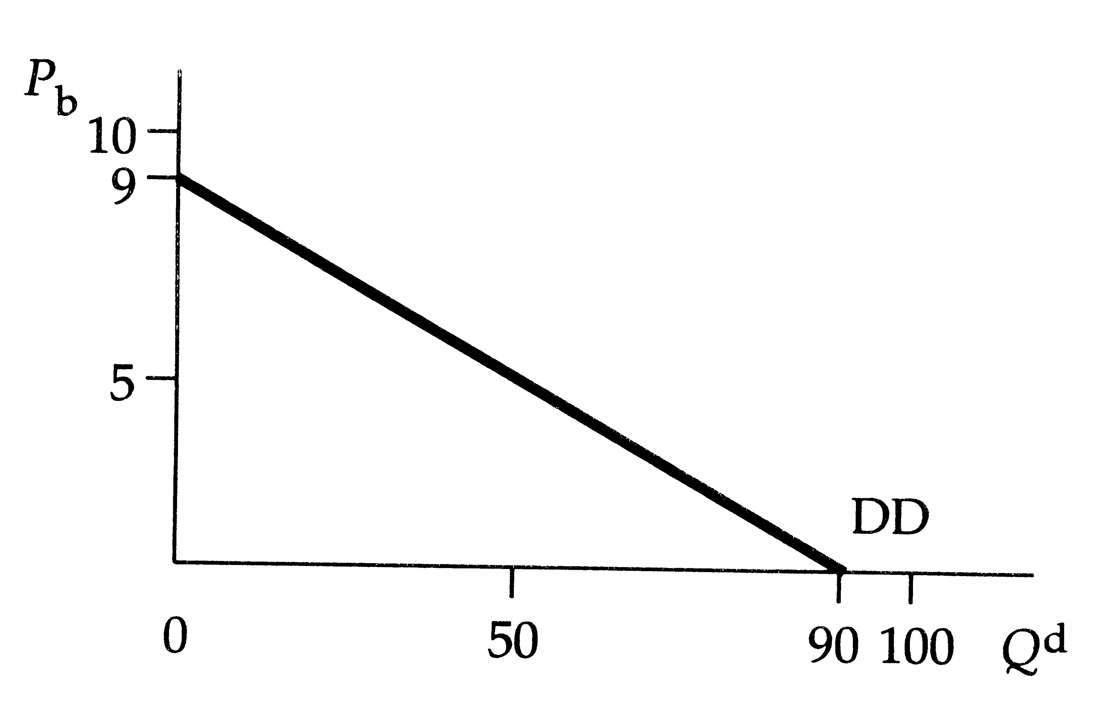

57. The study of macroeconomics depends mainly upon the historical data on different economies. Macroeconomists analyze these data to explain changes occurring in different economic parameters (income, prices, unemployment, etc.) and formulate policies. Additionally, macroeconomic studies cannot be conducted in controlled experiments, as in biology or chemistry, for example. In this way, the job of macroeconomists is similar to the job of weather forecasters.

58.
a. | Q = 60 loaves, Pb = $3.00
b. | Q = 70 loaves, Pb = $3.50

59. With flexible prices, instantaneous adjustment in prices to changes in demand and supply brings market forces into equilibrium. In contrast, sticky prices can lead to shortages or surpluses in response to changes in supply or demand.

60.
a. | The equilibrium price is $5.50, and the equilibrium quantity is 16.
b. | Pc and Q
c. | PT and PE

61. An exogenous variable is the variable that an economic model assumes to be given. For example, in the supply and demand models below, the income of consumers (Graph 1) and the cost of materials (Graph 2) are assumed to be given.
Now if there is a change in the income of consumers, this affects the market outcome.
In Graph 1 (below), increase in income shifts the demand curve upward from D₁ to D₂, with increased quantity from Q₁ to Q₂, and also increases the prices from P₁ to P₂.
In Graph 2 (below), the exogenous variable is the cost of materials. A rise in the cost of materials decreases the supply from S₁ to S₂. Quantity falls from Q₁ to Q₂, and prices rise from P₁ to P₂.
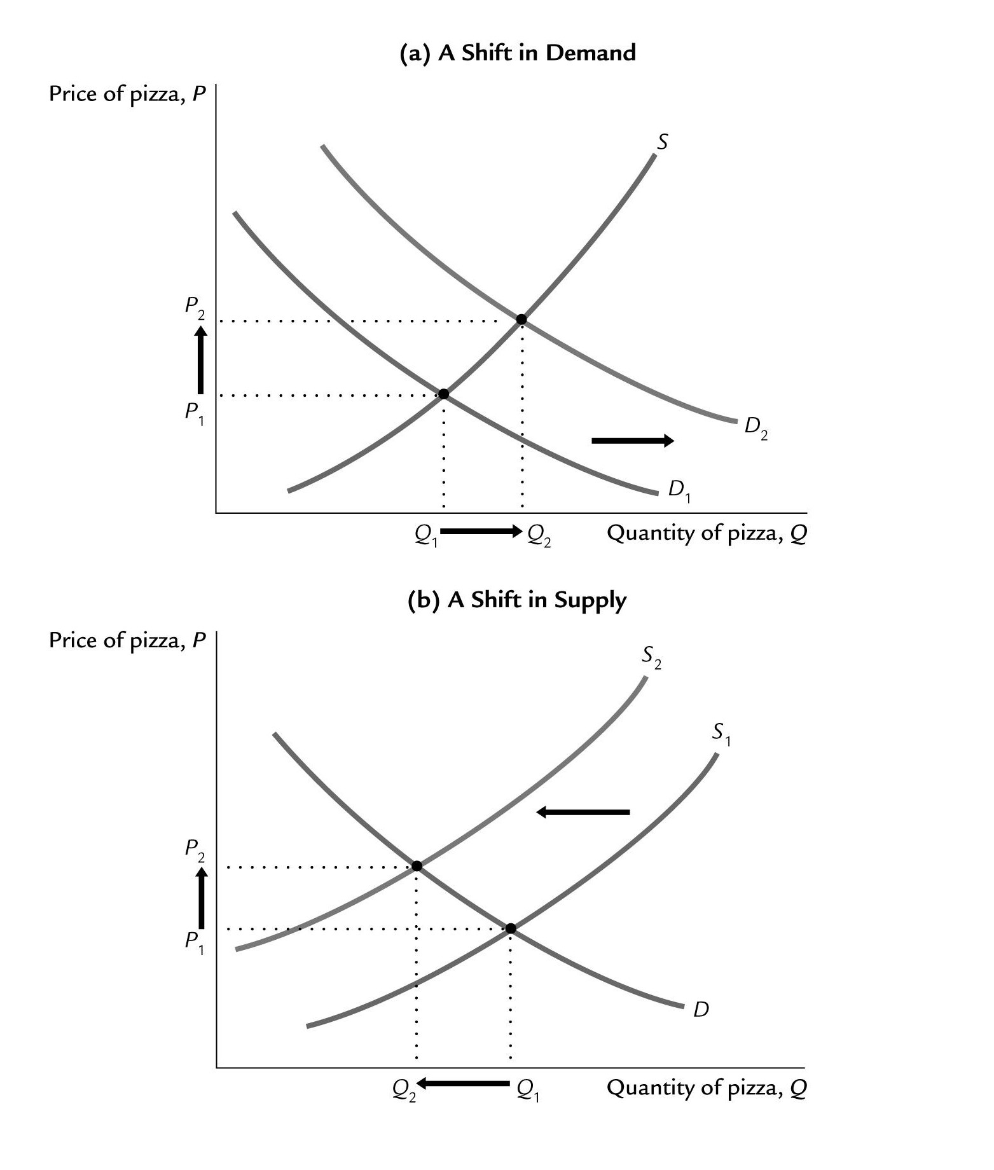

62. The income of a person is a microeconomic variable, while the gross domestic product (GDP) of your country is a macroeconomic variable. The money a person saves in the bank is a microeconomic variable, while the total money in all banks and post offices of your country is a macroeconomic variable.

63. Country A experienced its recession during 2003 and its early recovery during 2004. Country B experienced its first recession during 2002 and its early recovery in 2003. Country B experienced a second recession in 2007.

