Chapter 1
What Is Statistics?
1. a. Interval b. Ratio
c. Nominal d. Nominal
e. Ordinal f. Ratio (LO1-5)

2. a. Ratio b. Nominal
c. Ratio d. Ratio (LO1-5)

3. Answer will vary. (LO1-5)

4. a. Sample b. Population
c. Population d. Sample (LO1-3)

5. Qualitative data is not numerical, whereas quantitative data is numerical. Examples will vary by student. (LO1-4)

6. A population is the entire group which you are studying. A sample is a subset taken from a population. (LO1-3)

7. Discrete variables can assume only certain values, but continuous variables can assume any values within some range. Examples will vary. (LO1-4)

8. a. A population is used because the professor likely has grades readily available from every student over the past 5 years.
b. A population is employed because the information is easy to find.
c. A population is used because the information is easy to find.
d. A sample works because it is difficult to locate every musical. (LO1-3)

9. a. Ordinal
b. Ratio
c. The newer system provided information on the distance between exits. (LO1-5)

10. The cell phone provider is nominal level data. The minutes used are ratio level. Satisfaction is ordinal level. (LO1-5)

11. If you were using this store as typical of all Barnes & Noble stores then it would be sample data. However, if you were considering it as the only store of interest, then the data would be population data. (LO1-3)

12. In a presidential election all votes are counted, thus it is similar to a census of the entire population. However, an “exit” poll consists of only some voters and thus is more like a sample of the entire population. (LO1-3)

13.

 | Discrete | Continuous
Qualitative | b. Gender  d. Soft drink preference  g. Student rank in class  h. Rating of a finance professor
Quantitative | c. Sales volume of MP3 players  f. SAT scores  i. Number of home computers | a. Salary  e. Temperature

 | Discrete | Continuous
Nominal | b. Gender
Ordinal | d. Soft drink preference  g. Student rank in class  h. Rating of a finance professor
Interval | f. SAT scores | e. Temperature
Ratio | c. Sales volume of MP3 players  i. Number of home computers | a. Salary

(LO1-4 and LO1-5)

14. Answers will vary. (LO1-5)

15. As a result of these sample findings, we can conclude that 120/300 or 40% of the white-collar workers would transfer outside the U.S. (LO1-3)

16. The obvious majority of consumers (400/500, or 80%) believe the policy is fair. On the strength of these findings, we can anticipate a similar proportion of all customers to feel the same. (LO1-3)
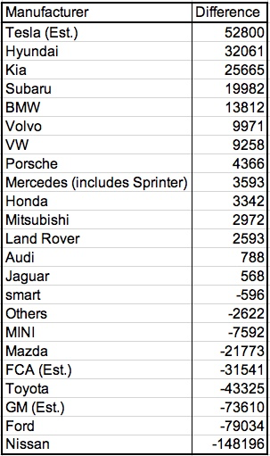17. a

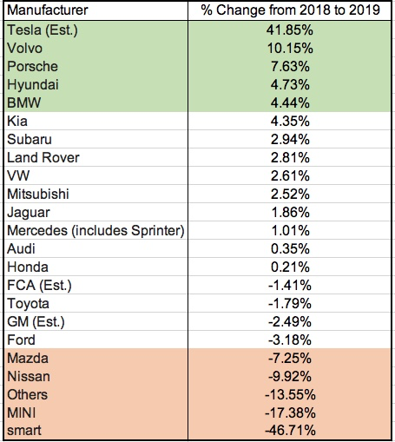b. Percentage differences with top five and bottom five.

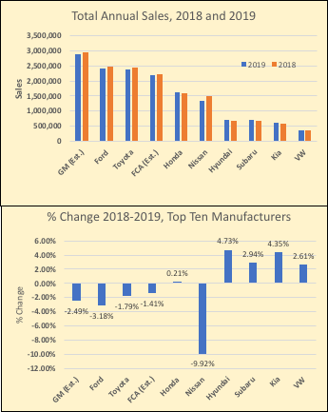c. (LO1-2)

18. The total amount spent is $603.86. The percentages by group are: 75, 14, 4, and 7, respectively. (LO1-2)

19. Earnings increase about $15 billion per year over the period. However 2008 sees a very large increase and 2009 sees a large decrease.
Perhaps the earnings were affected by the financial “collapse” during the years 2008-2010.
Perhaps the variability of earnings from 2013 to 2017 are related to supply and demand of oil. Supply may have increased with new production in North Dakota. Demand may be affected by other sources of energy, such as wind and solar energy generation. Also, the use of natural gas to generate energy may be substituting for oil.
(LO1-2)

20. a. Qualitative variables: Pool, Garage, Township, Mortgage type, Default
Quantitative variables: Price, Bedrooms, Size, Baths, FICO Years (LO1-4)

b. Price measured in dollars: Continuous, Ratio scale
Agent: Nominal
Bedrooms are counted: Discrete, Ordinal??? Ratio scale
Size measured in area of square feet: Contiguous, Ratio scale
Pool measured as present or not: nominal
Garage measured as present or not: nominal
Baths are counted: Discrete, Ordinal?? Ratio scale
Township is labeled: nominal
Mortgage type measures as adjustable or fixed: nominal
FICO is an index of a person’s ability to pay their bills: ratio
Years are counted: ordinal
Default: measured as yes or no: nominal (LO1-5)

21. a. League is a qualitative variable; the others are quantitative. (LO1-4)
b. League is a nominal level variable; the others are ratio level variables. (LO1-5)

22. a. Bus Number, Manufacturer, and engine type are qualitative variables, the others are quantitative. (LO1-4)
b. Bus Number, Manufacturer, and Engine Type nominal level variables; the others are ratio level variables. (LO1-5)

