Indicate the answer choice that best completes the statement or answers the question.

1. Given 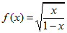and , calculate the composite functions and and determine their domains.
a.
b.
c.
d.
e.

2. Let and Calculate the composite functions and and determine their domains.
 | a. | ;
 | b. | ;
 | c. | ;
 | d. | ;
 | e. | ;

3. The domain and range of 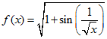are:
 | a. | Domain: ; range:
 | b. | Domain: ; range:
 | c. | Domain: ; range:
 | d. | Domain: ; range:
 | e. | Domain: ; range:

4. Complete the statement:
If and , then ___________________.
a.
b.
c.
d.
e.

5. Let 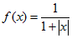and. Compute the composite functions and and determine their domains.
 | a. | ;
 | b. | ;
 | c. | ;
 | d. | ;
 | e. | ;

6. Complete the statement:
If 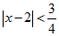and , then _____________________.
a.
b.
c.
d.
e.

7. Let 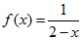and . Calculate the composite functions and and determine their domains.
a.
b.
c.
d.
e.

8. The domain and range of 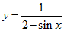are:
 | a. | Domain: ; range:
 | b. | Domain: ; range:
 | c. | Domain: ; range:
 | d. | Domain: ; range:
 | e. | Domain: ; range:

9. The domain and range of the function are:
 | a. | Domain: ; range:
 | b. | Domain: ; range:
 | c. | Domain: ; range:
 | d. | Domain: ; range:
 | e. | Domain: ; range:

10. The domain and the range of the function 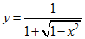are:
 | a. | Domain: ; range:
 | b. | Domain: ; range:
 | c. | Domain ; range:
 | d. | Domain: ; range:
 | e. | Domain: ; range:

11. Solve the following equation for if :
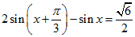

12. Find the point of intersection of the following lines:
The line parallel to and passing through the midpoint of the segment connecting the points and .
The line perpendicular to and passing through .

13. Find if 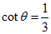and

14. State whether the following functions are even, odd, or neither:
A)
B)
C) 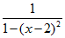
D)

15. What is the maximum possible value of if x must satisfy the inequality ?

16. Let 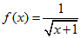and . Find all values of such that the domain of is all of R.

17. Compute, , and if and is acute.

18. Solve the following equation for if :
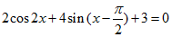

19. Let and 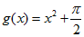. Calculate the composite functions and and determine their domains.

20. Referring to the figure, find the value of .
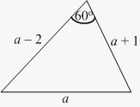

21. Determine real numbers and so that the line with -intercept at 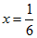is perpendicular to the line .

22. Find the point on the line closest to the origin. What is the distance between this point and the origin?

23. What is the distance between the maximum point on the parabola and the minimum point on the parabola ?

24. A line is perpendicular to and passes through . What is the y-coordinate of the point on the line whose x-coordinate is ?

25. Compute , , and if 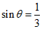and is acute.

26. Complete the square and find the maximum value of 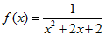.

27. Let 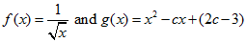. Find all values of such that the domain of is .

28. Find the interval over which the function 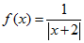is increasing.

29. Let 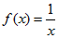and 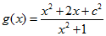. Find all values of so that the domain of is .

30. Find the interval over which the function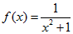 is increasing.

31. Find the point on the line closest to the point . What is the distance between the two points?

32. Find the x-coordinates of the points of intersection of the graphs of and for .

33. For which values of does the parabola y = have no real roots?

34. Find the points of intersection of the two graphs and for .

35. Find the points where the graphs of and intersect for .

36. Determine whether the following functions are even, odd, or neither:
A)
B) 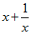
C)
D) 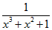

37. Find the set of values of satisfying both and 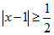.

38. What is the coefficient of x in the expansion of (2 – 3x)⁶?

39. Find the minimum and maximum values of if .

40. Find the maximum value of if x must satisfy the inequality .

41. Compute , , and if and 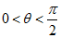.

42. What is the coefficient of x³ in the expansion of (x + 2)⁷?

43. The line in the figure is parallel to the diagonal (dashed segment) of the rectangle.
Find the y-coordinate of point.
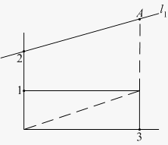

44. Find the radius of the circle with center that passes through .

45. The height of water in a certain bay changes over time according to a function of the form , where A, B, C, and D are real numbers. One day, a high tide of 8 ft occurred at 4 AM and low tide of 2 ft occurred at 2 PM. Determine values of A, B, C, and D so that the function H(t) describes this scenario, where H(t) is measured in feet and t is the number of hours since 12 AM.

46. Compute and if 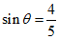and 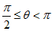.

47. Find the domain and range of the function 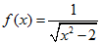.

48. What is the maximum value of if x must satisfy the inequality ?

49. Find the point on the line that is closest to the point . What is the distance between the two points?

50. Find the equation of the line perpendicular to and passing through . What is the -coordinate of the point on this line whose x-coordinate is ?

51. Let and . Find all values of such that the domain of is .

52. Find the points of intersection of the graphs of and 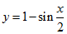for .

53. Find the value of such that the point lies on the line of slope through the point 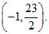

54. Referring to the figure, compute the value of .
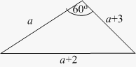

55. State whether the following functions are even, odd or neither:
A) 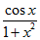
B) 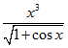
C)
D)

56. Solve the following equation for if :
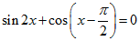

57. Find the equation of the circle passing through the point and whose center is located at the midpoint of the line segment joining and .

58. Find the point of intersection of the following lines:
The line with slope 2 passing through the midpoint of the segment joining the points and .
The line perpendicular to and passing through .

59. Solve the following equation for if :
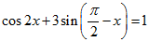

60. Use the addition formula to compute 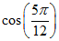exactly.

61. Find the minimum value of the angle between the segment joining a point on the graph of with the origin, and the -axis for .
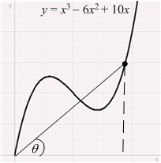

62. Solve the following equation for if :

63. You are buying a video game system on layaway. You deposit $100 and make weekly payments. The amount you owe after w weeks is given by the function A(w) = 400 – 40w.
A) What is the slope and what does it mean in this context?
B) What is the y-intercept and what does it mean in this context?
C) What was the original cost of the gaming console?
D) How many weeks does it take to pay off the gaming console?

64. Find the solution sets of the following inequalities:
A)
B)

65. What is the maximum possible value of if x must satisfy the inequality ?

66. Find the set of values of satisfying both and .

67. Find the point on the line closest to the point .

68. Find the greatest and smallest values of such that satisfies the inequalities and .

69. What is the coefficient of x² in the expansion of (3 – x)⁵?

70. Find the maximum value of if x must satisfy the inequality .

71. Suppose that . What are the minimum and maximum possible values of ?

72. Let , . Find the value of in the interval (–2, 3), such that the points and are farthest.
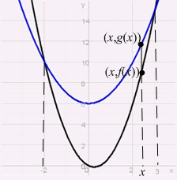

73. Compute , , and if and is acute.

74. A research study suggests the relationship between the total goals made, x, by the highest-paid National Hockey League (NHL) centers and their annual salaries that season, y, is described by the linear equation y = 7,500,000 + 300,000x.
A) What is the slope and what does it mean in this context?
B) What is the y-intercept and what does it mean in this context?

75. Suppose that is even and is odd. Determine whether the following functions are even, odd, or neither, in general:
A)
B)
C)
D) 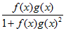

76. Find the minimum and maximum values of for satisfying and .

77. Find the greatest and the smallest values of such that satisfies the inequalities and .

78. Let 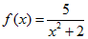and . Calculate the composite function and determine its domain and range.

79. Referring to the figure, find the equation of the line containing the altitude from point to side of the triangle. What is the -coordinate of the point on this line whose x-coordinate is ?
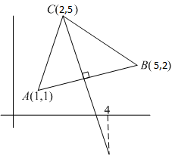

Answer Key
1. d

2. c

3. b

4. a

5. a

6. b

7. b

8. a

9. a

10. d

11. 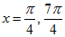

12.

13. 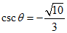

14. A) Even
B) Odd
C) Neither
D) Even

15. 9

16.

17. 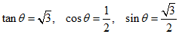

18. ,

19. 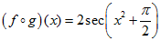
Domain: 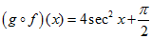
Domain:

20.

21.

22.

23.

24. 0

25. 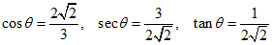

26. 1

27.

28.

29.

30.

31. 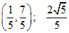

32. 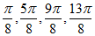

33. 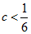

34. 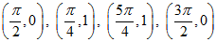

35. 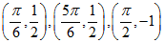

36. A) Even
B) Odd
C) Even
D) Neither

37. (–1, 6)

38. -576

39. Minimum: 0; maximum: 7

40. 9

41. 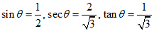

42. 560

43. 3

44.

45.

46. 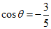, 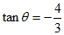

47. Domain: 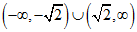
Range:

48.

49. 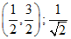

50. y = 2x + 5; y = –7 when x = –6

51.

52. , 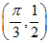,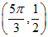

53. 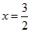

54.

55. A) Even
B) Odd
C) Neither
D) Neither

56. 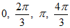

57.

58.

59. 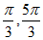

60. 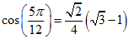

61. 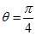

62. 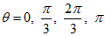

63. A) –40; the amount that the total still owed decreases per week
B) 400; the amount owed after making the initial deposit of $100
C) $500
D) 10 weeks

64. A) (–1/3, 5)
B) (–4, 9)

65.

66. (1, 9)

67. (2, 4)

68. Minimum: 1; maximum: 5

69. 270

70. 16

71. Minimum: 0; maximum: 10

72. 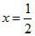

73. 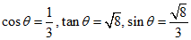

74. A) 300,000; the amount the annual salary increases for every goal made
B) 7,500,000; the salary if the center made zero goals that season

75. A) Even
B) Neither
C) Even
D) Odd

76. Minimum: 0; maximum: 11

77. 6, 1

78. 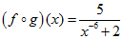
Domain: ; range: 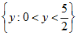

79. y = –4x +13; y = –3 when x = 4

